Spring cloud tools and apis
Spring cloud stream :
Spring Cloud Stream is a framework for building highly scalable event-driven microservices connected with shared messaging systems.
The framework provides a flexible programming model built on already established and familiar Spring idioms and best practices, including support for persistent pub/sub semantics, consumer groups, and stateful partitions.

Binder Implementations
Spring Cloud Stream supports a variety of binder implementations and the following table includes the link to the GitHub projects.
- RabbitMQ
- Apache Kafka
- Kafka Streams
- Amazon Kinesis
- Google PubSub (partner maintained)
- Solace PubSub+ (partner maintained)
- Azure Event Hubs (partner maintained)
- Apache RocketMQ (partner maintained)
The core building blocks of Spring Cloud Stream are:
- Destination Binders: Components responsible to provide integration with the external messaging systems.
- Destination Bindings: Bridge between the external messaging systems and application code (producer/consumer) provided by the end user.
- Message: The canonical data structure used by producers and consumers to communicate with Destination Binders (and thus other applications via external messaging systems).
The annotation @EnableBinding configures the application to bind the channels INPUT and OUTPUT defined within the interface Processor. Both channels are bindings that can be configured to use a concrete messaging-middleware or binder.
Let's take a look at the definition of all these concepts:
- Bindings — a collection of interfaces that identify the input and output channels declaratively
- Binder — messaging-middleware implementation such as Kafka or RabbitMQ
- Channel — represents the communication pipe between messaging-middleware and the application
- StreamListeners — message-handling methods in beans that will be automatically invoked on a message from the channel after the MessageConverter does the serialization/deserialization between middleware-specific events and domain object types / POJOs
- Message Schemas — used for serialization and deserialization of messages, these schemas can be statically read from a location or loaded dynamically, supporting the evolution of domain object types

3.2. Communication Patterns
Messages designated to destinations are delivered by the Publish-Subscribe messaging pattern. Publishers categorize messages into topics, each identified by a name. Subscribers express interest in one or more topics. The middleware filters the messages, delivering those of the interesting topics to the subscribers.
Now, the subscribers could be grouped. A consumer group is a set of subscribers or consumers, identified by a group id, within which messages from a topic or topic's partition are delivered in a load-balanced manner.

Apache JMeter™
The Apache JMeter™ application is open source software, a 100% pure Java application designed to load test functional behavior and measure performance. It was originally designed for testing Web Applications but has since expanded to other test functions.

What can I do with it?
Apache JMeter may be used to test performance both on static and dynamic resources, Web dynamic applications.
It can be used to simulate a heavy load on a server, group of servers, network or object to test its strength or to analyze overall performance under different load types.
Apache JMeter features include:
- Ability to load and performance test many different applications/server/protocol types:
  - Web - HTTP, HTTPS (Java, NodeJS, PHP, ASP.NET, …)
  - SOAP / REST Webservices
  - FTP
  - Database via JDBC
  - LDAP
  - Message-oriented middleware (MOM) via JMS
  - Mail - SMTP(S), POP3(S) and IMAP(S)
  - Native commands or shell scripts
  - TCP
  - Java Objects
- Full featured Test IDE that allows fast Test Plan recording (from Browsers or native applications), building and debugging.
- CLI mode (Command-line mode (previously called Non GUI) / headless mode) to load test from any Java compatible OS (Linux, Windows, Mac OSX, …)
- A complete and ready to present dynamic HTML report
- Easy correlation through ability to extract data from most popular response formats, HTML, JSON , XML or any textual format
- Complete portability and 100% Java purity.
- Full multi-threading framework allows concurrent sampling by many threads and simultaneous sampling of different functions by separate thread groups.
- Caching and offline analysis/replaying of test results.
- Highly Extensible core:
  - Pluggable Samplers allow unlimited testing capabilities.
  - Scriptable Samplers (JSR223-compatible languages like Groovy and BeanShell)
  - Several load statistics may be chosen with pluggable timers.
  - Data analysis and visualization plugins allow great extensibility as well as personalization.
  - Functions can be used to provide dynamic input to a test or provide data manipulation.
  - Easy Continuous Integration through 3rd party Open Source libraries for Maven, Gradle and Jenkins.

1.0.2 Load Test running
Once your Test Plan is ready, you can start your Load Test. The first step is to configure the injectors that will run JMeter, this as for any other Load Testing tool includes:
- Correct machine sizing in terms of CPU, memory and network
- OS Tuning
- Java setup: Ensure you install the latest version of Java supported by JMeter
- Increase the Java Heap size. By default JMeter runs with a heap of 1 GB, this might not be enough for your test and depends on your test plan and number of threads you want to run
Once everything is ready, you will use CLI mode (Command-line mode previously called Non-GUI mode) to run it for the Load Test.
Don't run load test using GUI mode !
Using CLI mode, you can generate a CSV (or XML) file containing results and have JMeter generate an HTML report at end of Load Test. JMeter will by default provide a summary of load test while it's running.
You can also have real-time results during your test using Backend Listener.

Spring Cloud Session-4 Inter Microservice Communication ASynchronous using Kafka
In this tutorial we are going to learn how microservices communicate with each other in asynchronous fashion. In asynchronous communication calling microservice will not wait till the called microservice responds. This pattern can be achieved with message bus infrastructures like Kafka.Here we use Spring Cloud Stream framework to communicate with message bus.
Overview
- When report-api microservice receives a request to get employee details it is going to fetch details and write results to message bus.
- Mail microservice listens on the bus for employee details and when those details are available on bus. It is going to read send SMS and email.
- report-api play a role of Producer
- mail-client microservice plays a role of Consumer
- Kafka play a role of mediator or message bus
Flow
- Run Kafka server, it binds to port 9092 and admin ui application (Control Center web interface) to port 9021.
- Run registry service on 8761.
- Run employee-api service on dynamic port. Where it takes employee id and returns employee name.
- Run payroll-api service on dynamic port. Where it takes employee id and returns employee salary.
- Run report-api service on dynamic port. Where it takes employee id and returns employee name and salary by directly communicating with employee-api and payroll-api. It also publishes employee details to message bus
- Run mail-client service (it is not a rest api, it a java process and doesn't bind to any port). Where it subscribes to message bus for employee details message and sends mail,sms.
- Run Gateway service on 8080 and reverse proxy requests to all the services (employee-api,payroll-api,report-api)
- All the microservices (employee-api,payroll-api,report-api,gateway) when they startup they register their service endpoint (rest api url) with registry
- Gateway Spring Cloud load balancer (Client side load balancing) component in Spring Cloud Gateway acts as reverse proxy. It reads a registry for microservice endpoints and configures routes.
Important Notes
- Netflix Eureka Server plays a role of Registry. Registry is a spring boot application with Eureka Server as dependency.
- Netflix Eureka Client is present in all the micro services (employee-api,payroll-api,report-api,gateway) and they discover Eureka server and register their availability with server.
- Generally Netflix Ribbon Component is used as Client Side load balancer, but it is deprecated project. We will be using Spring Cloud Load balaner in gateway

Source Code
git clone https://github.com/balajich/spring-cloud-session-4-inter-microservice-communication-async-kafka.git

Video
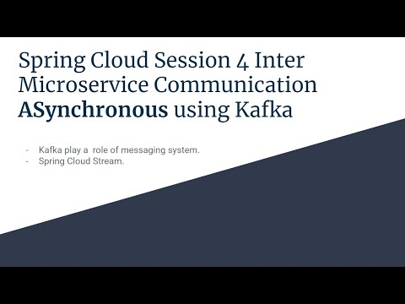
- https://youtu.be/sP2WcMutbn0

Architecture
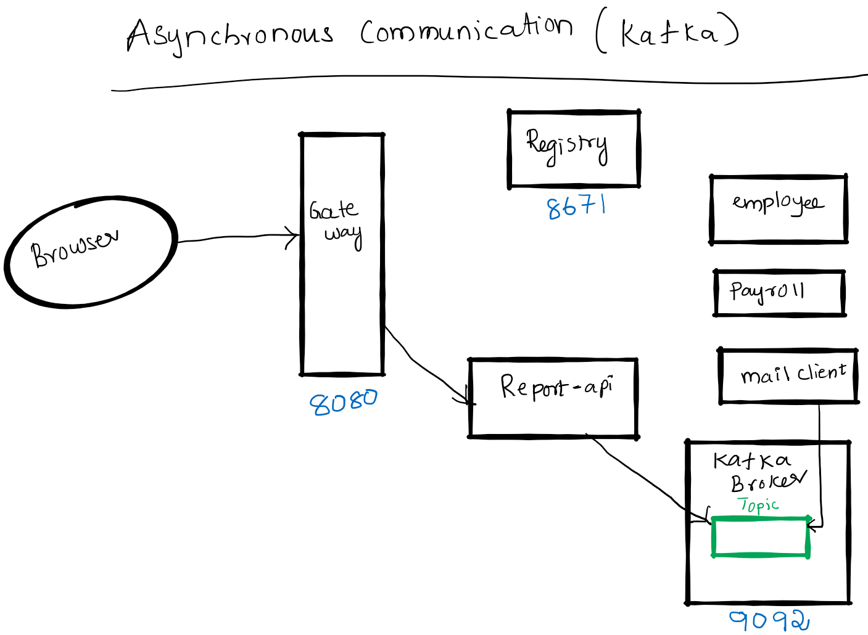

Kafka Terminology
- Producer, publisher A Producer is the application that is sending the messages Kafka server.
- Consumer A Consumer is the application that receives the messages from the Kafka server.
- Message- A message is a simple array of bytes.
- Kafka Broker - Broker is a Kafka server.
- Topic - Producer sends message to topic and consumer reads message from topic. Note: We are not covering concepts like Partitions,Offsets,Consumer Groups ..etc. Please check my kafka tutorial blog.

Spring Cloud Stream Concepts
Spring cloud stream abstracts underneath communication with Messagebus. This helps to foucs on business logic instead of nettigritty of message bus. We can easily switch from Kafka to Kafka etc without code changes.
- Bindings — a collection of interfaces that identify the input and output channels.
- Channel — represents the communication pipe between messaging-middleware and the application.
- StreamListeners- Listens to messages on Input channel and serializes them to java objects.

Prerequisite
- JDK 1.8 or above
- Apache Maven 3.6.3 or above
- Vagrant, Virtualbox (To run Kafka Server)

Start Kafka Server and Build Microservices
We will be running Kafka server inside a docker container. I am running docker container on CentOS7 virtual machine. I will be using vagrant to stop or start a virtual machine.
- Kafka Server
  - cd spring-cloud-session-4-inter-microservice-communication-async-kafka
  - Bring virtual machine up vagrant up
  - ssh to virtual machine vagrant ssh
  - Switch to root user sudo su -
  - Change folder where docker-compose files is available cd /vagrant
  - Start Kafka Server using docker-compose docker-compose up -d
- Java
  - mvn clean install

Kafka Server Admin UI (Control Center web interface)
- http://localhost:9021/clusters
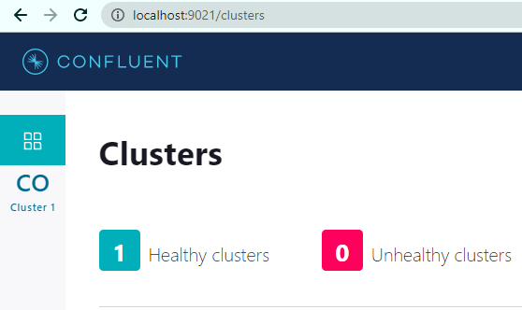

Running components
- Registry: java -jar .\registry\target\registry-0.0.1-SNAPSHOT.jar
- Employee API: java -jar .\employee-api\target\employee-api-0.0.1-SNAPSHOT.jar
- Payroll API: java -jar .\payroll-api\target\payroll-api-0.0.1-SNAPSHOT.jar
- Report API: java -jar .\report-api\target\report-api-0.0.1-SNAPSHOT.jar
- Mail Client App: java -jar .\mail-client\target\mail-client-0.0.1-SNAPSHOT.jar
- Gateway: java -jar .\gateway\target\gateway-0.0.1-SNAPSHOT.jar

Using curl to test environment
Note I am running CURL on windows, if you have any issue. Please use postman client, its collection is available at spring-cloud-session-3-inter-microservice-communication-sync.postman_collection.json
- Access Kafka UI: http://localhost:9021/clusters
- Get employee report using report api ( direct): curl -s -L http://localhost:8080/report-api/100

Code
In this section will focus only on report-api code which publishes employee details to queue queue.email
ReportController in app report-api. @SendTo(Processor.OUTPUT) makes the function to invoke Kafka and writes details to topic queue.email.
@SendTo(Processor.OUTPUT)
public Employee getEmployeeDetails(@PathVariable int employeeId) {

Employee finalEmployee = new Employee(responseEmployeeNameDetails.getId(), responseEmployeeNameDetails.getName(), responseEmployeePayDetails.getSalary());
// Send to message bus
processor.output().send(MessageBuilder.withPayload(finalEmployee).build());

}
application.yml in report-api.
cloud:
stream:
bindings:
output:
destination: queue.email
kafka:
binder:
brokers: 127.0.0.1
defaultBrokerPort: 9092
mail-client code that reads messages from queue. @StreamListener(Processor.INPUT) reads data from queue email.queue
@SpringBootApplication
@EnableBinding(Processor.class)
public class MailClientApplication {

public static void main(String[] args) {
SpringApplication.run(MailClientApplication.class, args);
}

@StreamListener(Processor.INPUT)
public void receivedEmail(Employee employee) {
System.out.println("Received employee details: " + employee);
System.out.println("Sending email and sms: "+employee.getName());
}

}
application.yml of mail-client
spring:
application:
name: email-api
cloud:
stream:
bindings:
input:
destination: queue.email
group: emailconsumers
kafka:
binder:
brokers: 127.0.0.1
defaultBrokerPort: 9092

References
- https://www.baeldung.com/spring-cloud-stream
- Spring Microservices in Action by John Carnell
- Hands-On Microservices with Spring Boot and Spring Cloud: Build and deploy Java microservices using Spring Cloud, Istio, and Kubernetes -Magnus Larsson
- https://medium.com/@ruwansriw/apache-kafka-terminology-f0b5350c26e4

FAQ
- https://github.com/balajich/Spring-Cloud-Sessions-Microservices-FAQ/blob/master/README.md

Next Tutorial
Document microservices using OpenAPI/Swagger
- https://github.com/balajich/spring-cloud-session-5-microservices-documentation

Spring Cloud Session 5 Microservices Documentation
In this tutorial we are going to learn how do we document REST API microservices using OpenAPI/Swagger.
- Swagger is one of the mostly used standard while documenting REST API services.
- We will use SpringFox to produce Swagger/OpenAPI documentation.
Overview
- We will be using SpringFox to document employee-api , payroll-api
- API documentation will be viewed via gateway.
- Access Swagger UI of employee-api and make few rest calls.
- Import OpenAPI definition to postman to generate client code.
Important Notes
- Please refer my previous sessions to understand how these microservices work. In this session we will focus on documenting API and accessing API documentation.
- Using SpringFox we can have API code and documentation present in same source files, This makes api documentation doesn't go out of sync with code.
- In 2015, SmartBear Software donated the Swagger specification to the Linux Foundation under the OpenAPI Initiative and created the OpenAPI Specification. To create the API documentation, we will use SpringFox.
- We will not be focusing on in depth SpringFox annotations our goal is to quickly enable documentation for RESTAPI.

Source Code
git clone https://github.com/balajich/spring-cloud-session-5-microservices-documentation.git

Video
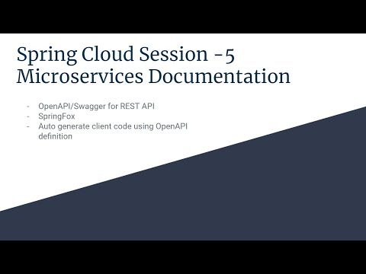
- https://youtu.be/RjPAX3pkBq4

Architecture
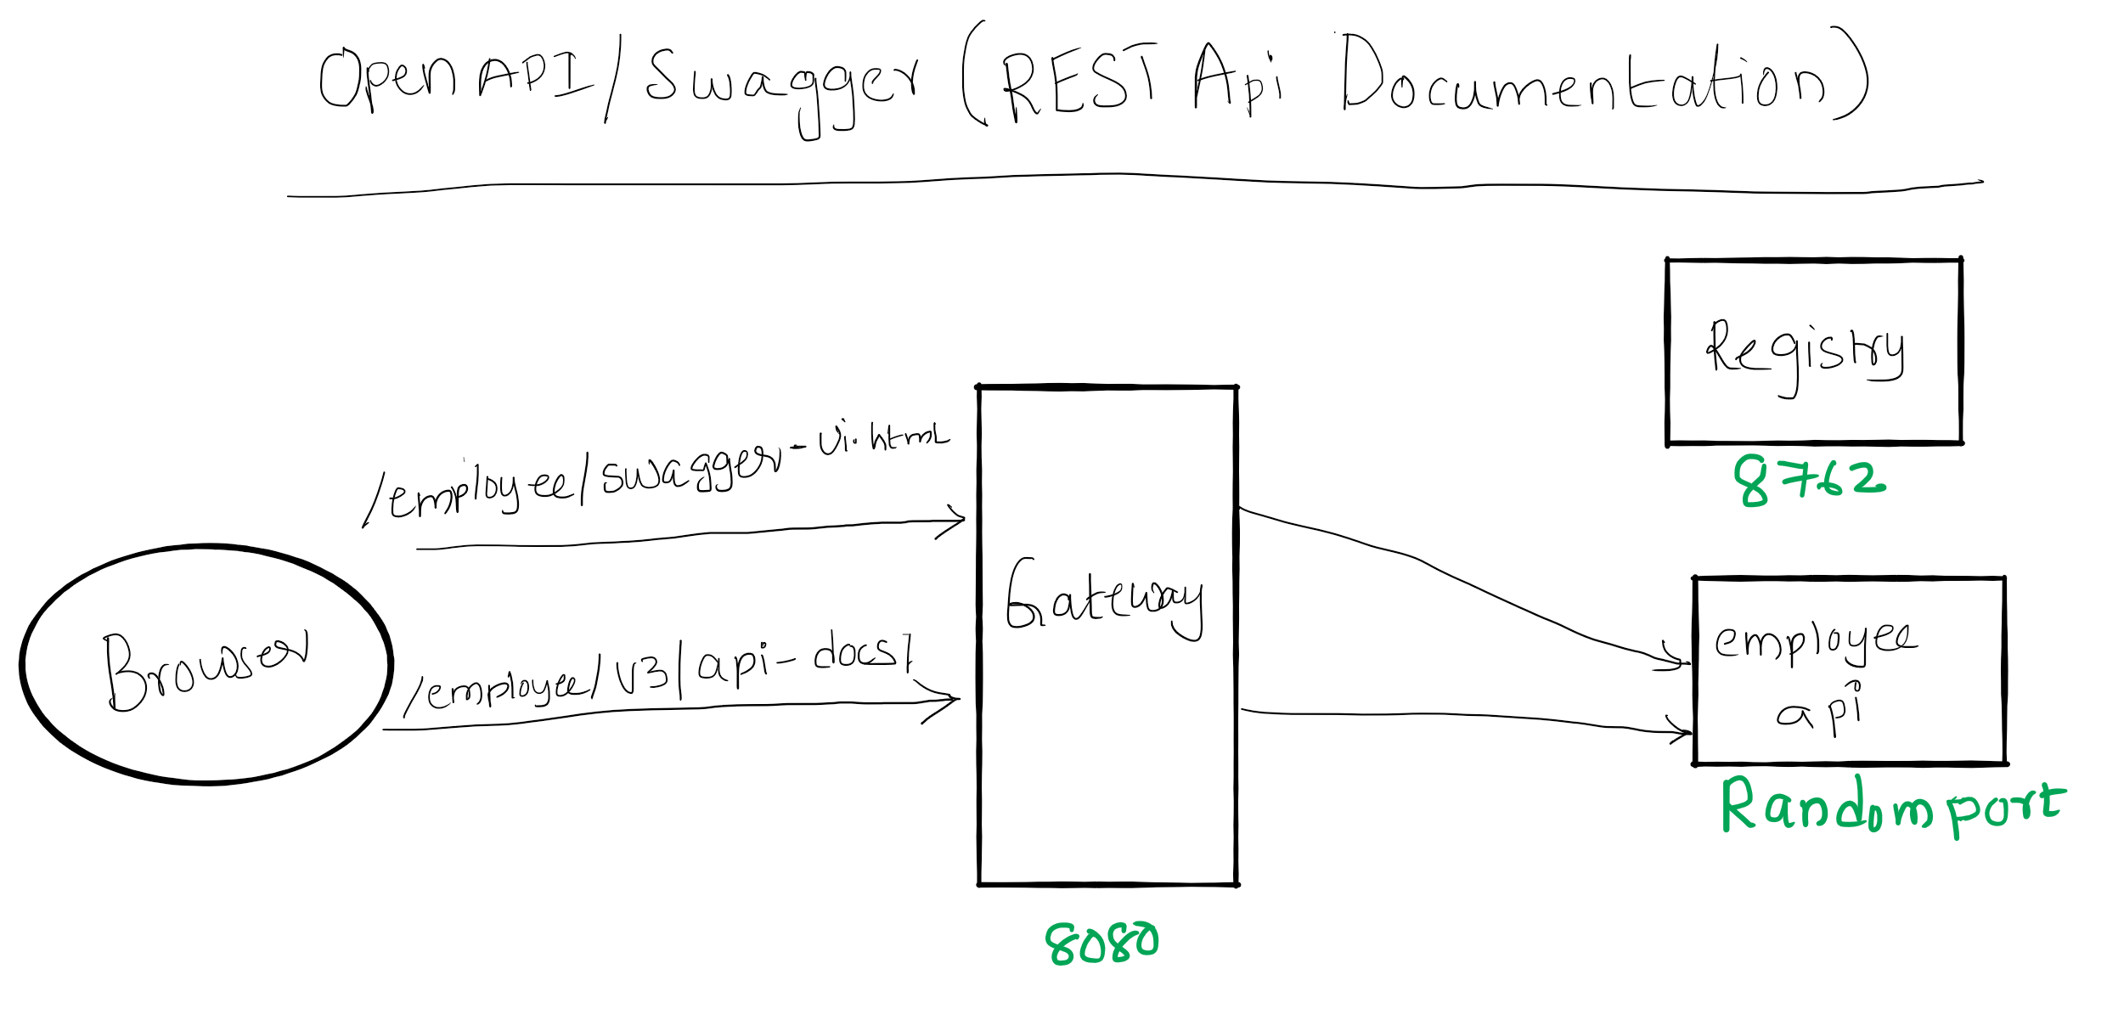

Prerequisite
- JDK 1.8 or above
- Apache Maven 3.6.3 or above

Clean and Build
- Java
  - cd spring-cloud-session-5-microservices-documentation
  - mvn clean install

Running components
- Registry: java -jar .\registry\target\registry-0.0.1-SNAPSHOT.jar
- Employee API: java -jar .\employee-api\target\employee-api-0.0.1-SNAPSHOT.jar
- Payroll API: java -jar .\payroll-api\target\payroll-api-0.0.1-SNAPSHOT.jar
- Gateway: java -jar .\gateway\target\gateway-0.0.1-SNAPSHOT.jar

Accessing Swagger UI of employee and payroll api
- OpenAPI definition of employee api curl -s -L http://localhost:8080/employee/v3/api-docs/
- Swagger UI of employee api via gateway: http://localhost:8080/employee/swagger-ui.html
- OpenAPI descriptions of payroll api curl -s -L http://localhost:8080/payroll/v3/api-docs/
- Swagger UI of payroll api via gateway: http://localhost:8080/payroll/swagger-ui.html
- You can use postman collection Spring Cloud Session 5 Microservices Documentation.postman_collection.json

Code
In employee-api pom.xml add dependency springdoc-openapi-ui.
<dependency>
<groupId>org.springdoc</groupId>
<artifactId>springdoc-openapi-ui</artifactId>
<version>1.2.32</version>
</dependency>
Set swagger-ui and api-docs paths to be accessible on employee context, So that they can be accessed from gateway easily. application.yml
springdoc:
swagger-ui:
path: /employee/swagger-ui.html
api-docs:
path: /employee/v3/api-docs/
Note: I didn't customize the documentation generated by SpringFox, if need please use appropriate annotations.

Next Steps
- How deploy microservices using docker

References
- Hands-On Microservices with Spring Boot and Spring Cloud: Build and deploy Java microservices using Spring Cloud, Istio, and Kubernetes -Magnus Larsson
- Spring Microservices in Action by John Carnell

Next Tutorial
- https://github.com/balajich/spring-cloud-session-6-microservices-deployment-docker

Resilience4j Session-5 Preventing cascading of failures in REST API using Circuit Breaker
In this tutorial we are going to learn how to prevent cascading of failures from one service to other service using Resilience4j Circuit Breaker module.
For example if a ServiceA depends up on ServiceB. For some reason ServiceB is experiencing error instead of repeatedly calling ServiceB, the ServiceA should take a break (not calling) until ServiceB is completely or half recovered.
- Using Circuit Breaker we can prevent flow of failures to downstream/upstream.
- This functionality can be achieved easily with annotation @CircuitBreaker without writing explicit code.
Overview
- User makes a call to get greeting message from REST API ServiceA
- ServiceA calls ServiceB to fetch greeting message
- Because of some random issue 50% of calls to ServiceB results in failure
- When ever ServiceA gets error message from ServiceB instead of returning error message to client, it will return message from a cache.
- When ever error rate increases beyond 50% ServiceA doesn't call ServiceB until ServiceB recovers or waitDurationInOpenState is finished
- This entire functionality can be achieved with Circuit Breaker pattern

Source Code
- https://github.com/balajich/resilience4j-helloworld/tree/master/circuitbreaker-error-calls

Video
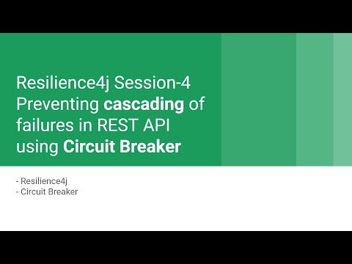
- https://youtu.be/_hCyRcJcCks

Architecture
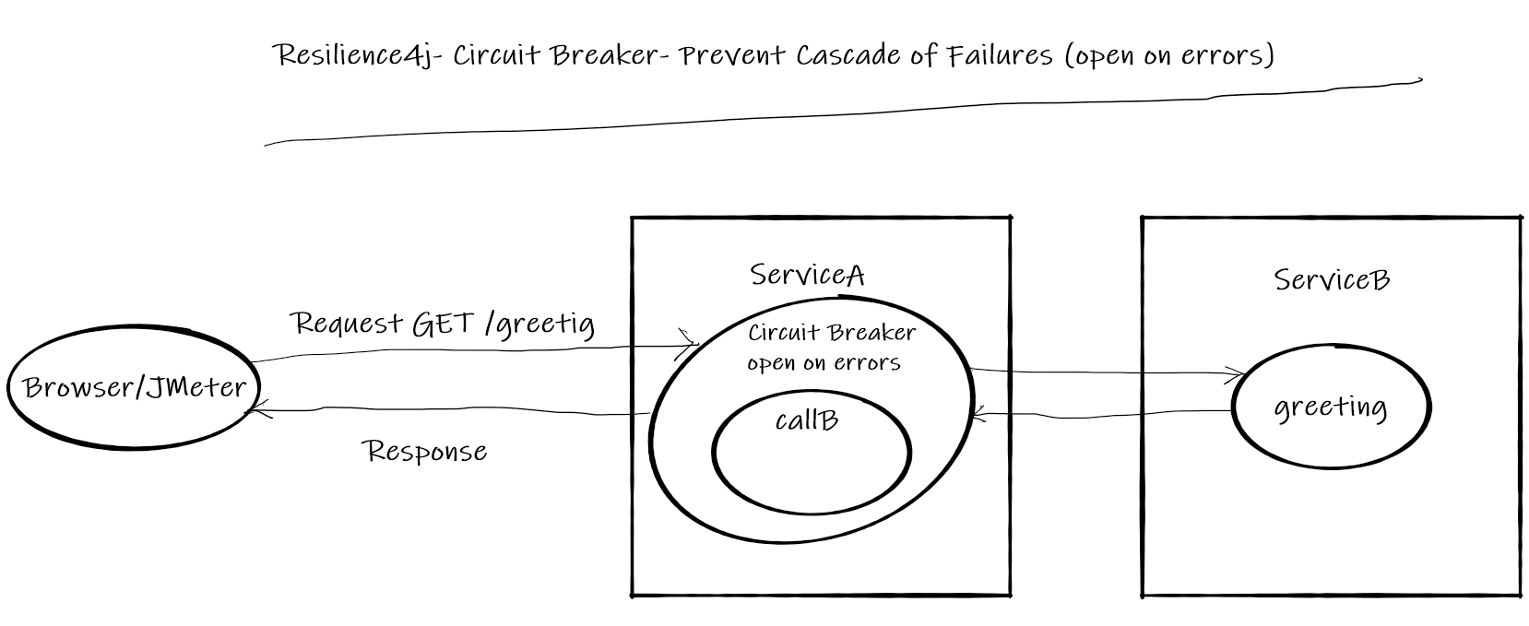

Normal Call flow
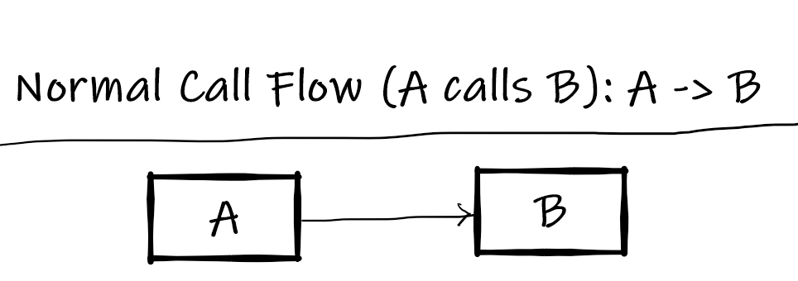

Call flow with Circuit Breaker
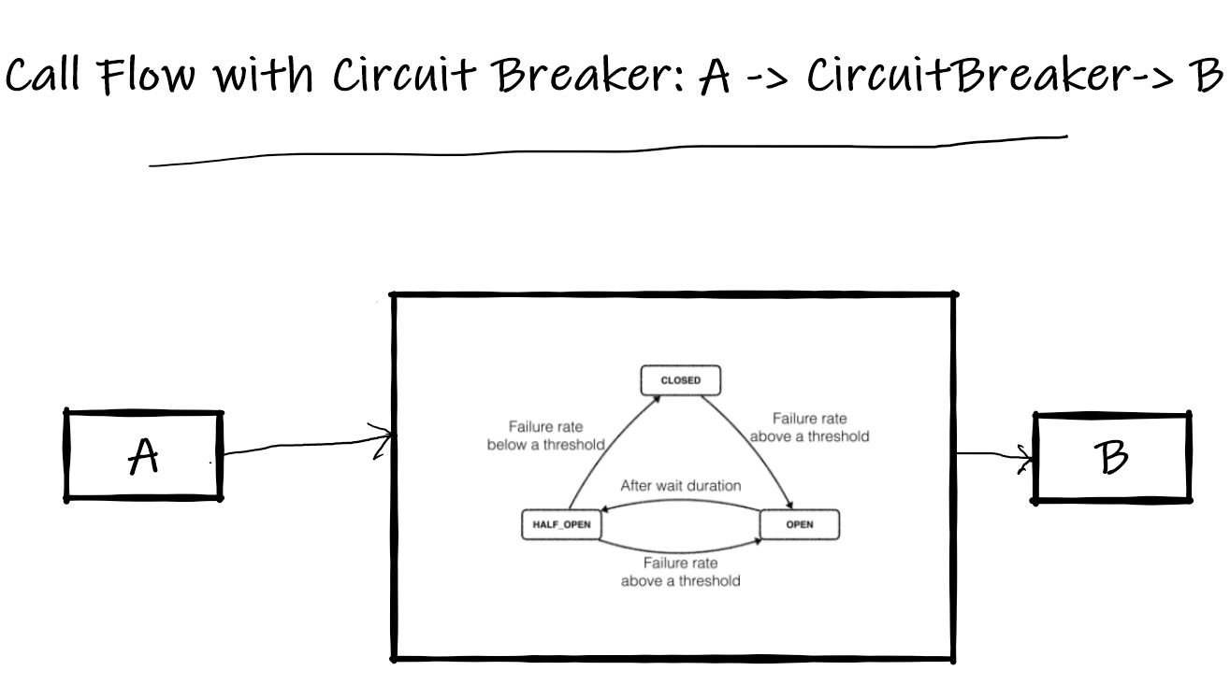

Prerequisite
- JDK 1.8 or above
- Apache Maven 3.6.3 or above

Build
- cd resilience4j-helloworld\circuitbreaker-error-calls
- mvn clean install

Running
- ServiceA: java -jar .\servicea\target\servicea-0.0.1-SNAPSHOT.jar
- ServiceB: java -jar .\serviceb\target\serviceb-0.0.1-SNAPSHOT.jar

Using JMeter to test environment
- JMeter Script is provided to generate call.
- Import resilience4j-helloworld.jmx and run circuitbreaker-error-calls-serviceb thread group.
- Observe ServiceB will generate 50% of errors
- 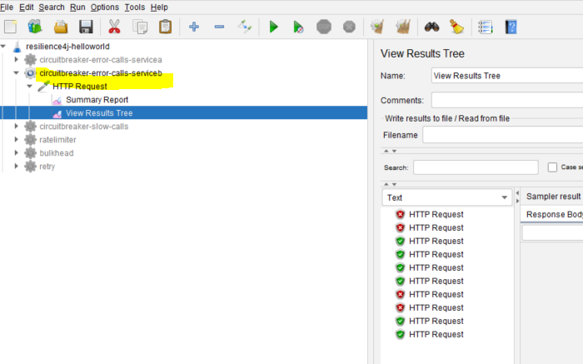
- run circuitbreaker-error-calls-servicea thread group.
- Observe ServiceA will generate 100% of success even ServiceB returns errors, Further more it doesn't makes calls to ServiceB until it recovers.
- 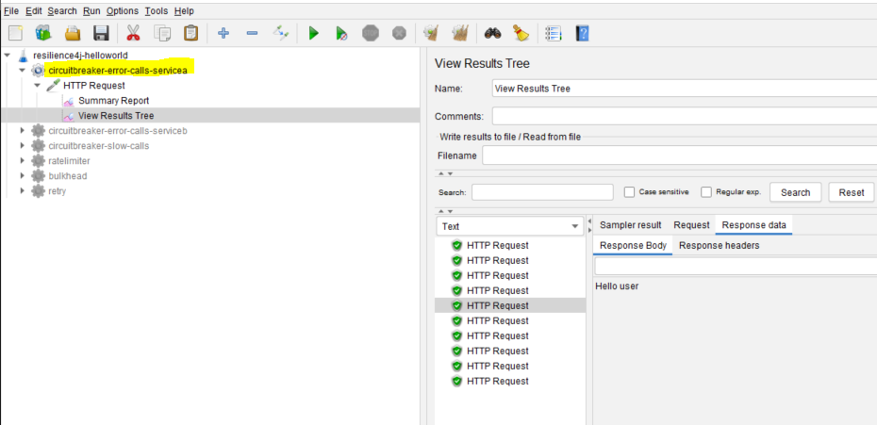

Code
Include following artifacts as dependency for spring boot restapi ServiceA application. resilience4j-spring-boot2, spring-boot-starter-actuator,spring-boot-starter-aop pom.xml for ServiceA
<dependency>
<groupId>io.github.resilience4j</groupId>
<artifactId>resilience4j-spring-boot2</artifactId>
<version>1.4.0</version>
</dependency>
<dependency>
<groupId>org.springframework.boot</groupId>
<artifactId>spring-boot-starter-actuator</artifactId>
</dependency>
<dependency>
<groupId>org.springframework.boot</groupId>
<artifactId>spring-boot-starter-aop</artifactId>
</dependency>
In application.yml of ServiceA define the behavior of Circuit Breaker module
- slidingWindowSize: Configures the size of the sliding window which is used to record the outcome of calls when the CircuitBreaker is closed.
- slidingWindowType: Configures the type of the sliding window which is used to record the outcome of calls when the CircuitBreaker is closed
- minimumNumberOfCalls: Configures the minimum number of calls which are required (per sliding window period) before the CircuitBreaker can calculate the error rate or slow call rate.
- waitDurationInOpenState: The time that the CircuitBreaker should wait before transitioning from open to half-open.
- waitDuration: A fixed wait duration between retry attempts
- retryExceptions: Configures a list of error classes that are recorded as a failure and thus are retried.
- failureRateThreshold: Configures the failure rate threshold in percentage.
resilience4j:
circuitbreaker:
configs:
default:
slidingWindowSize: 10
slidingWindowType: COUNT_BASED
minimumNumberOfCalls: 5
permittedNumberOfCallsInHalfOpenState: 3
automaticTransitionFromOpenToHalfOpenEnabled: true
waitDurationInOpenState: 1s
instances:
greetingCircuit:
baseConfig: default
failureRateThreshold: 50
recordExceptions:
- org.springframework.web.client.HttpServerErrorException
@GetMapping("/greeting")
@CircuitBreaker(name = "greetingCircuit", fallbackMethod = "greetingFallBack")
public ResponseEntity greeting(@RequestParam(value = "name", defaultValue = "World") String name) {
ResponseEntity responseEntity = restTemplate.getForEntity("http://localhost:8081/**ServiceB**greeting?name=" + name, String.class);
//update cache
cache = responseEntity.getBody().toString();
return responseEntity;
}

//Invoked when circuit is in open state
public ResponseEntity greetingFallBack(String name, io.github.resilience4j.circuitbreaker.CallNotPermittedException ex) {
System.out.println("Circuit is in open state no further calls are accepted");
//return data from cache
return ResponseEntity.ok().body(cache);
}

//Invoked when call to **ServiceB** failed
public ResponseEntity greetingFallBack(String name, HttpServerErrorException ex) {
System.out.println("Exception occurred when call calling service B");
//return data from cache
return ResponseEntity.ok().body(cache);
}
ServiceB is a simple rest api application, which generates 50% of faiulres
Random random = new Random(-6732303926L);
@GetMapping("/serviceBgreeting")
public ResponseEntity greeting(@RequestParam(value = "name", defaultValue = "**ServiceB**") String name) {
return generateErrorBehavior(name);
}

private ResponseEntity generateErrorBehavior(String name) {
int i = random.nextInt(2);
if (i == 0) {
System.out.println("Service B Generated Exception");
return ResponseEntity.status(HttpStatus.INTERNAL_SERVER_ERROR).body("Service B Generated Exception");
}
return ResponseEntity.ok().body("Hello " + name);
}

Weblink
- https://eduami.org/Resilience4j/circuitbreaker-error-calls.html

References
- https://resilience4j.readme.io/docs/circuitbreaker
- https://developer.mozilla.org/en-US/docs/Web/HTTP/Status
- https://www.baeldung.com/resilience4j
- Hands-On Microservices with Spring Boot and Spring Cloud: Build and deploy Java microservices using Spring Cloud, Istio, and Kubernetes -Magnus Larsson

Next Tutorial
How to deploy microservices using docker
- https://github.com/balajich/spring-cloud-session-6-microservices-deployment-docker
Resilience4j Building Fault Tolerant REST API

Resilience4j- Session-1 Limit number of requests to RESTAPI using ratelimiter
In this tutorial we are going to learn how to limit number of requests that a restapi can handle in a fixed duration. There are several reasons to limit number of calls than an api can hanlde,few of them are.
- To meet service level agreement
- Protect resources from an overload and Denial of Service (DoS) attacks
Overview
- Using Ratelimit limit the number of call that a service can handle.
- This functionality can be achieved easily with annotation @RateLimiter without writing explicit code.
Overview
- User makes a call to greeting RESTAPI to get a greeting message.
- greeting can only handle 5 requests in a second.
- This limitation can be set on greeting method using annotation @RateLimiter
- if the method receives more than 5 requests an exception io.github.resilience4j.ratelimiter.RequestNotPermitted is thrown and user is served with HTTP status code 429 (Too Many Requests)

Source Code
- https://github.com/balajich/resilience4j-helloworld/tree/master/ratelimiter

Video
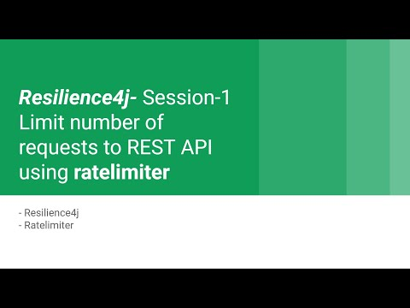
- https://youtu.be/j9cH01mlK6k

Architecture
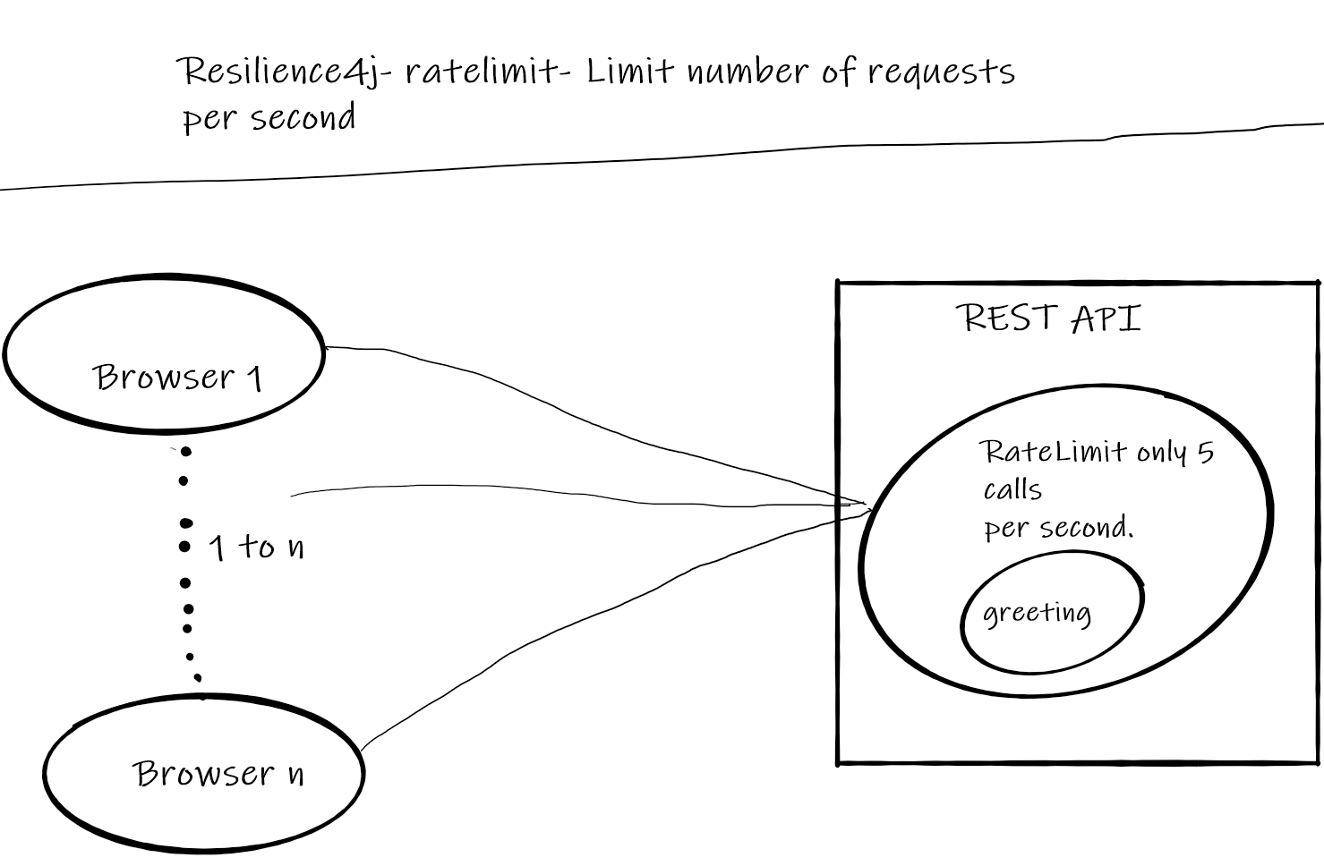

Prerequisite
- User should have basic understanding of RESTAPI and Spring boot
- JDK 1.8 or above
- Apache Maven 3.6.3 or above

Build
- cd resilience4j-helloworld
- mvn clean install

Running RESTAPI
- REST API Server: java -jar .\ratelimiter\target\ratelimiter-0.0.1-SNAPSHOT.jar

Using JMeter to generate more than 5 calls in a second
- JMeter Script is provided to generate calls
- Import resilience4j-helloworld.jmx and run ratelimiter thread group.
- 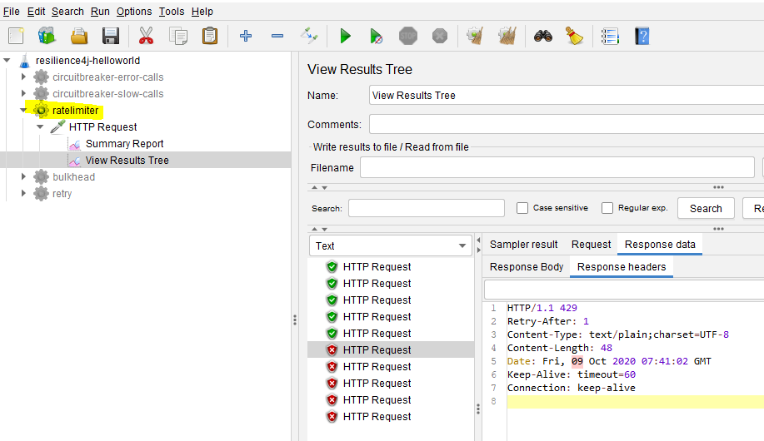

Code
Include following artifacts as dependency for spring boot restapi application. resilience4j-spring-boot2, spring-boot-starter-actuator,spring-boot-starter-aop pom.xml of ratelimiter
<dependency>
<groupId>io.github.resilience4j</groupId>
<artifactId>resilience4j-spring-boot2</artifactId>
<version>1.4.0</version>
</dependency>
<dependency>
<groupId>org.springframework.boot</groupId>
<artifactId>spring-boot-starter-actuator</artifactId>
</dependency>
<dependency>
<groupId>org.springframework.boot</groupId>
<artifactId>spring-boot-starter-aop</artifactId>
</dependency>
In application.yml define the behavior of ratelimiter module
- limitForPeriod: The number of calls allowed during period.
- limitRefreshPeriod: Reset the limit period .
- timeoutDuration: Duration for which request should wait.
resilience4j:
ratelimiter:
configs:
default:
limitForPeriod: 5
limitRefreshPeriod: 1s
timeoutDuration: 0
instances:
greetingRateLimit:
baseConfig: default
@GetMapping("/greeting")
@RateLimiter(name = "greetingRateLimit", fallbackMethod = "greetingFallBack")
public ResponseEntity greeting(@RequestParam(value = "name", defaultValue = "World") String name) {
return ResponseEntity.ok().body("Hello World: " + name);
}

public ResponseEntity greetingFallBack(String name, io.github.resilience4j.ratelimiter.RequestNotPermitted ex) {
System.out.println("Rate limit applied no further calls are accepted");

HttpHeaders responseHeaders = new HttpHeaders();
responseHeaders.set("Retry-After", "1"); //retry after one second

return ResponseEntity.status(HttpStatus.TOO_MANY_REQUESTS)
.headers(responseHeaders) //send retry header
.body("Too many request - No further calls are accepted");
}

References
- https://developer.mozilla.org/en-US/docs/Web/HTTP/Status
- https://www.baeldung.com/resilience4j
- Hands-On Microservices with Spring Boot and Spring Cloud: Build and deploy Java microservices using Spring Cloud, Istio, and Kubernetes -Magnus Larsson

Next Tutorial
How to deploy microservices using docker
- https://github.com/balajich/spring-cloud-session-6-microservices-deployment-docker

Resilience4j Session-3 Making RESTAPI fault tolerant using Retry
In this tutorial we are going to learn how make spring boot based RESTAPI fault tolerant. Under certain circumstances we observe that subsystem works well when we retry the same request. To handle such scenarios we can use resilience4j retry module.
- Using Retry module automatically retry a failed call.
- This functionality can be achieved easily with annotation @Retry without writing explicit code.
Overview
- User makes a call to get greeting message from REST API ServiceA
- ServiceA calls ServiceB to fetch greeting message
- Because of some random issue 50% of calls to ServiceB results in failure
- When ever ServiceA gets error message from ServiceB instead of returning error message to client,it will retry three times.
- Even after three time if ServiceB returns error , error is retuned to user.
- This entire functionality can be achieved without writing explicit code using Retry.

Source Code
- https://github.com/balajich/resilience4j-helloworld/tree/master/retry

Video
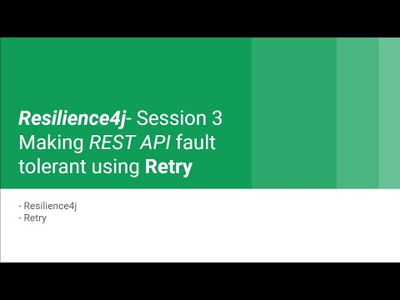
- https://youtu.be/b6g5FqFuvrs

Architecture
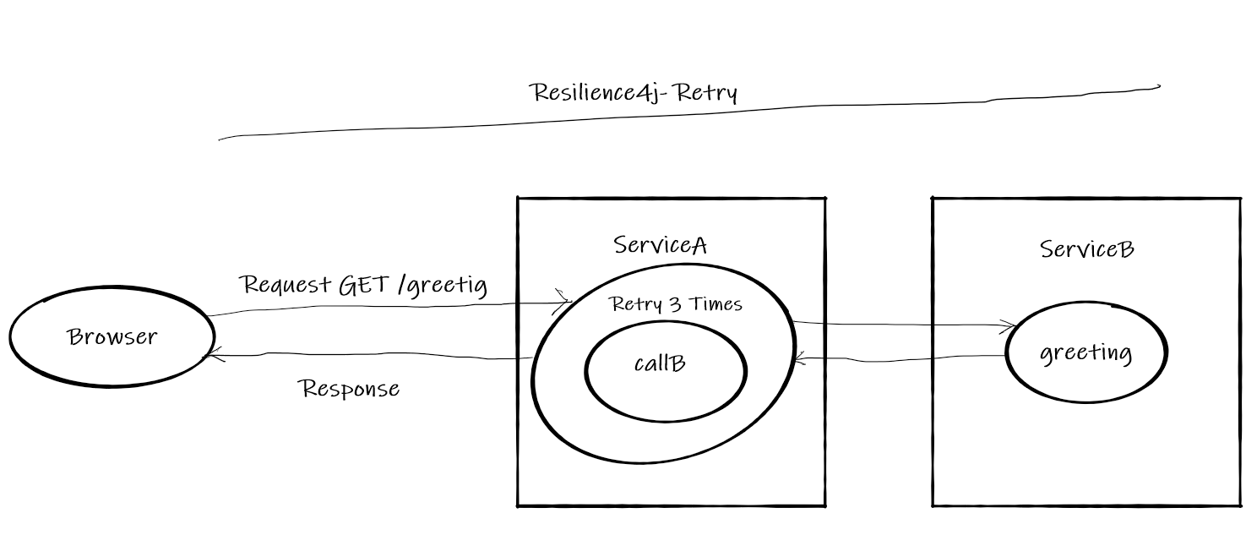

Prerequisite
- JDK 1.8 or above
- Apache Maven 3.6.3 or above

Build
- cd resilience4j-helloworld\retry
- mvn clean install

Running RESTAPI
- ServiceA: java -jar .\servicea\target\servicea-0.0.1-SNAPSHOT.jar
- ServiceB: java -jar .\serviceb\target\serviceb-0.0.1-SNAPSHOT.jar

Using JMeter to test environment
- JMeter Script is provided to generate call.
- Import resilience4j-helloworld.jmx and run retry-serviceb thread group.
- Observe ServiceB will generate 50% of errors
- 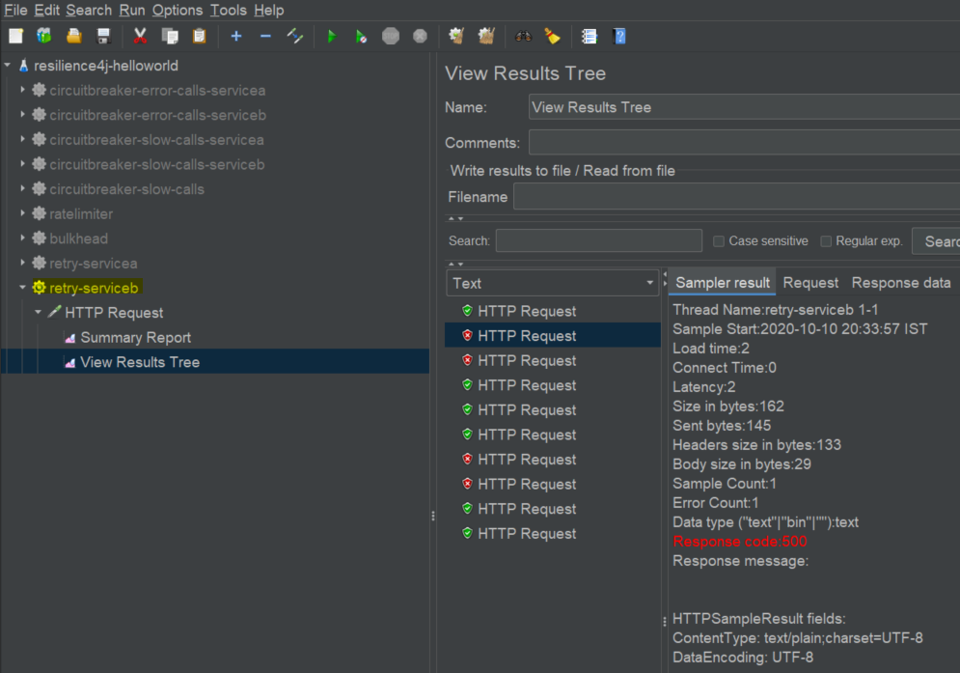
- run retry-servicea thread group.
- Observe ServiceA will generate 100% of success even ServiceB returns errors, This is because when ServiceA gets error from ServiceB it retries.
- 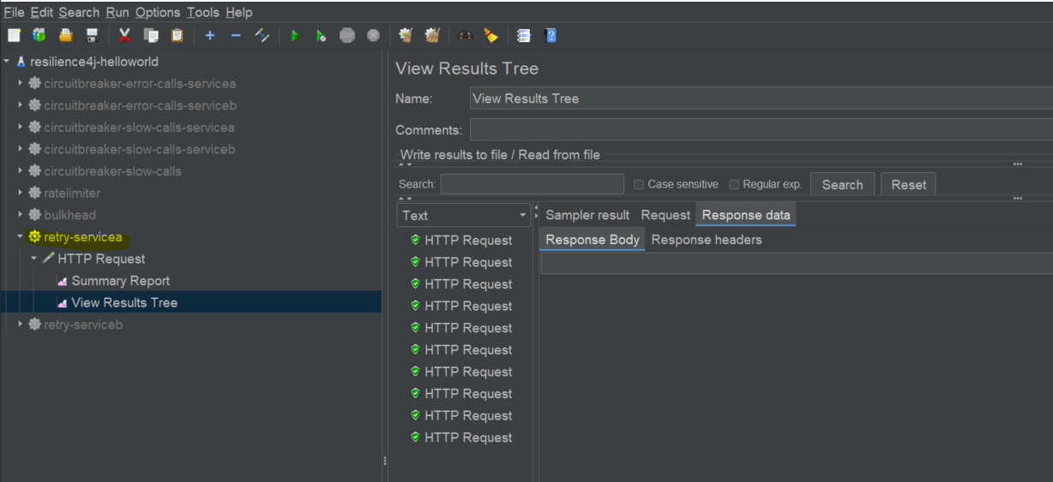

Code
Include following artifacts as dependency for spring boot restapi application. resilience4j-spring-boot2, spring-boot-starter-actuator,spring-boot-starter-aop pom.xml for ServiceA
<dependency>
<groupId>io.github.resilience4j</groupId>
<artifactId>resilience4j-spring-boot2</artifactId>
<version>1.4.0</version>
</dependency>
<dependency>
<groupId>org.springframework.boot</groupId>
<artifactId>spring-boot-starter-actuator</artifactId>
</dependency>
<dependency>
<groupId>org.springframework.boot</groupId>
<artifactId>spring-boot-starter-aop</artifactId>
</dependency>
In application.yml of define the behavior of retry module
- maxAttempts: The maximum number of retry attempts
- waitDuration: A fixed wait duration between retry attempts
- retryExceptions: Configures a list of error classes that are recorded as a failure and thus are retried. Retry function will be invoked a maximum of three times. For each and every successive invocation it will wait for 100 milliseconds. A retry will happen only when org.springframework.web.client.HttpServerErrorException is thrown by ServiceB.
resilience4j:
retry:
configs:
default:
maxAttempts: 3
waitDuration: 100ms
retryExceptions:
- org.springframework.web.client.HttpServerErrorException
instances:
greetingRetry:
baseConfig: default
@GetMapping("/greeting")
@Retry(name = "greetingRetry")
public ResponseEntity greeting(@RequestParam(value = "name", defaultValue = "World") String name) {
System.out.println("Greeting method is invoked");
ResponseEntity responseEntity = restTemplate.getForEntity("http://localhost:8081/**ServiceB**greeting?name=" + name, String.class);
//update cache
return responseEntity;
}
ServiceB is a simple springboot based REST API application. With generates 50% errors
Random random = new Random(-6732303926L);
@GetMapping("/**ServiceB**greeting")
public ResponseEntity greeting(@RequestParam(value = "name", defaultValue = "**ServiceB**") String name) {
return generateErrorBehavior(name);
}

private ResponseEntity generateErrorBehavior(String name) {
int i = random.nextInt(2);
if (i == 0) {
System.out.println("Service B Generated Exception");
return ResponseEntity.status(HttpStatus.INTERNAL_SERVER_ERROR).body("Service B Generated Exception");
}
return ResponseEntity.ok().body("Hello " + name);
}

References
- https://resilience4j.readme.io/docs/circuitbreaker
- https://developer.mozilla.org/en-US/docs/Web/HTTP/Status
- https://www.baeldung.com/resilience4j
- Hands-On Microservices with Spring Boot and Spring Cloud: Build and deploy Java microservices using Spring Cloud, Istio, and Kubernetes -Magnus Larsson

Web Link
- https://eduami.org/Resilience4j/retry.html

Next Tutorial
How to deploy microservices using docker
- https://github.com/balajich/spring-cloud-session-6-microservices-deployment-docker

Resilience4j Session-8 limit the amount of time spent calling a remote service
In this tutorial we are going to learn how to limit the amount of time spent calling a remote service using
Resilience4j TimeLimiter module.
For example if a ServiceA depends up on ServiceB. For some reason ServiceB is experiencing slowness instead of waiting endlessly for ServiceB to return. ServiceA will wait only for stipulated amount of time.
- This functionality can be achieved easily with annotation @TimeLimiter without writing explicit code.
Overview
- User makes a call to get greeting message from REST API ServiceA
- ServiceA calls ServiceB to fetch greeting message
- The usual response time of ServiceB is 10 milliseconds, Because of some random issue 50% of calls to ServiceB takes more than 2 seconds.
- This slowness behavior of ServiceB shouldn't impact ServiceA and its customers.
- When ever ServiceA sees a call to ServiceB taking more than 1 second, it cancels the call and return the data.
- In our example we return data from cache for slow calls instead of giving exception to client.

Source Code
- https://github.com/balajich/resilience4j-helloworld/tree/master/timelimiter-slow-calls

Video
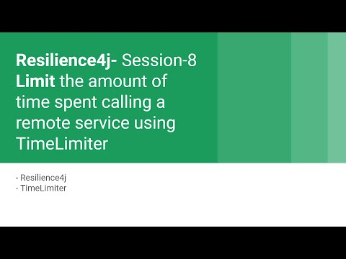
- https://youtu.be/ZqQiyiVDBc0

Architecture
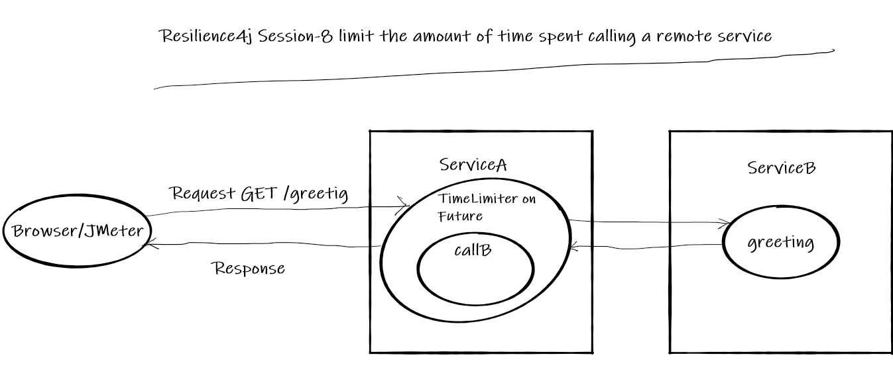

Prerequisite
- JDK 1.8 or above
- Apache Maven 3.6.3 or above

Build
- cd resilience4j-helloworld\timelimiter-slow-calls
- mvn clean install

Running
- ServiceA: java -jar .\servicea\target\servicea-0.0.1-SNAPSHOT.jar
- ServiceB: java -jar .\serviceb\target\serviceb-0.0.1-SNAPSHOT.jar

Using JMeter to test environment
- JMeter Script is provided to generate call.
- Import resilience4j-helloworld.jmx and run timelimiter-slow-calls thread group.
- This will generate 10 requests
- 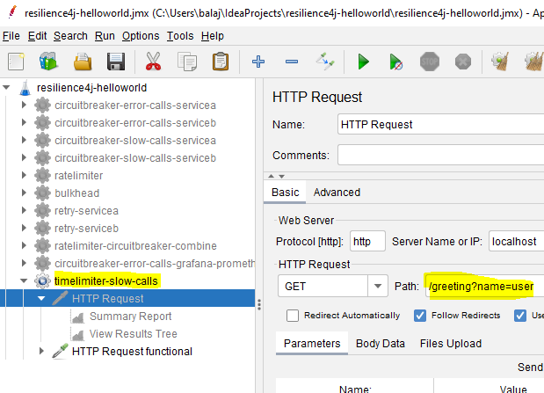

Code
Include following artifacts as dependency for spring boot restapi serviceA application. resilience4j-spring-boot2, spring-boot-starter-actuator,spring-boot-starter-aop pom.xml of ServiceA
<dependency>
<groupId>io.github.resilience4j</groupId>
<artifactId>resilience4j-spring-boot2</artifactId>
<version>1.4.0</version>
</dependency>
<dependency>
<groupId>org.springframework.boot</groupId>
<artifactId>spring-boot-starter-actuator</artifactId>
</dependency>
<dependency>
<groupId>org.springframework.boot</groupId>
<artifactId>spring-boot-starter-aop</artifactId>
</dependency>
In application.yml of serviceA define the behavior of TimeLimiter and Bulkhead module
- timeoutDuration- The amount time calling service needs to wait before generating timeout exception
- cancelRunningFuture- Cancel the Running Feature object
Note: Bulkhead module is added because TimeLimiter needs separate execution thread instead of request thread
resilience4j:
timelimiter:
configs:
default:
timeoutDuration: 1000
cancelRunningFuture: true
instances:
timelimiterSlow:
baseConfig: default
bulkhead:
configs:
default:
maxConcurrentCalls: 5
maxWaitDuration: 0
instances:
greetingBulkhead:
baseConfig: default
Annotation Approach: Greeting request controller of ServiceA
@GetMapping("/greeting")
@TimeLimiter(name = "timelimiterSlow", fallbackMethod = "greetingFallBack")
@Bulkhead(name = "greetingBulkhead", fallbackMethod = "greetingFallBack", type = Bulkhead.Type.THREADPOOL)
public CompletableFuture<String> greeting(@RequestParam(value = "name", defaultValue = "World") String name) {
String result = restTemplate.getForEntity("http://localhost:8081/serviceBgreeting?name=" + name, String.class).getBody().toString();
cache = result;//update cache
return CompletableFuture.completedFuture(result);
}

//Invoked when call to serviceB timeout
private CompletableFuture<String> greetingFallBack(String name, Exception ex) {
System.out.println("Call to serviceB is timed out");
//return data from cache
return CompletableFuture.completedFuture(cache);
}
Higher order decorator functions: Greeting request controller functional style of ServiceA
TimeLimiterConfig config = TimeLimiterConfig.custom()
.timeoutDuration(Duration.ofSeconds(1))
.cancelRunningFuture(true)
.build();
private String cache = null;

@Autowired
RestTemplate restTemplate;

@GetMapping("/greetingFunctional")
public ResponseEntity<String> greeting(@RequestParam(value = "name", defaultValue = "World") String name) {
String result = null;
try {
TimeLimiter timeLimiter = TimeLimiter.of(config);
result = timeLimiter.executeFutureSupplier(
() -> CompletableFuture.supplyAsync(() -> restTemplate.getForEntity("http://localhost:8081/serviceBgreeting?name=" + name, String.class).getBody()));
cache = result;
} catch (Exception e) {
// request time out
result = cache;

}
return ResponseEntity.ok().body(result);
}

Important Notes
- To decorate a TimeLimiter the method needs to return Future
- TimeLimiter annotation cannot cancel Future

References
- https://resilience4j.readme.io/docs/timeout
- https://reflectoring.io/time-limiting-with-resilience4j/
- https://www.baeldung.com/resilience4j

Next Tutorial
How to deploy microservices using docker
- https://github.com/balajich/spring-cloud-session-6-microservices-deployment-docker

Resilience4j Session-6 Applying multiple patterns (aspects) to a single service
In this tutorial we are going to learn how to add both Ratelimiter and CircuitBreaker patterns to a single service.
- Using Ratelimiter limit the number of call that a service can handle.
- Using Circuit Breaker we can prevent flow of failures to downstream/upstream.
Overview
- User makes a call to get greeting message from REST API ServiceA
- Limit ServiceA to handle only 10 calls per second.
- ServiceA calls ServiceB to fetch greeting message
- Because of some random issue 50% of calls to ServiceB results in failure.
- When ever ServiceA gets error message from ServiceB instead of returning error message to client, it will return message from a cache.
- When ever error rate increases beyond 50% ServiceA doesn't call ServiceB until ServiceB recovers or waitDurationInOpenState is finished
- This entire functionality can be achieved with Circuit Breaker and Ratelimiter pattern combined.

Source Code
- https://github.com/balajich/resilience4j-helloworld/tree/master/ratelimiter-circuitbreaker-combine

Video
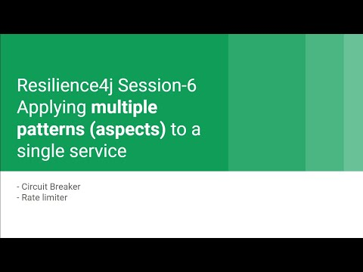
- https://youtu.be/ppOZ01vUhaw

Architecture
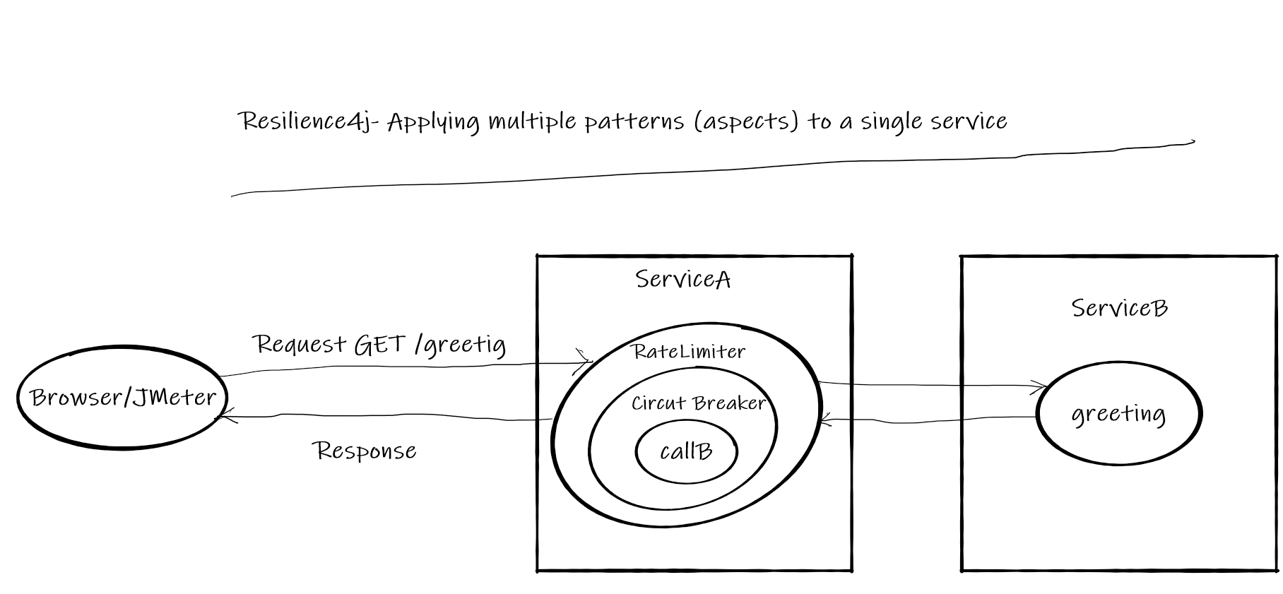

Prerequisite
- JDK 1.8 or above
- Apache Maven 3.6.3 or above

Build
- cd resilience4j-helloworld\ratelimiter-circuitbreaker-combine
- mvn clean install

Running
- ServiceA: java -jar .\servicea\target\servicea-0.0.1-SNAPSHOT.jar
- ServiceB: java -jar .\serviceb\target\serviceb-0.0.1-SNAPSHOT.jar

Using JMeter to test environment
- JMeter Script is provided to generate call.
- Import resilience4j-helloworld.jmx and run ratelimiter-circuitbreaker-combine thread group.
- 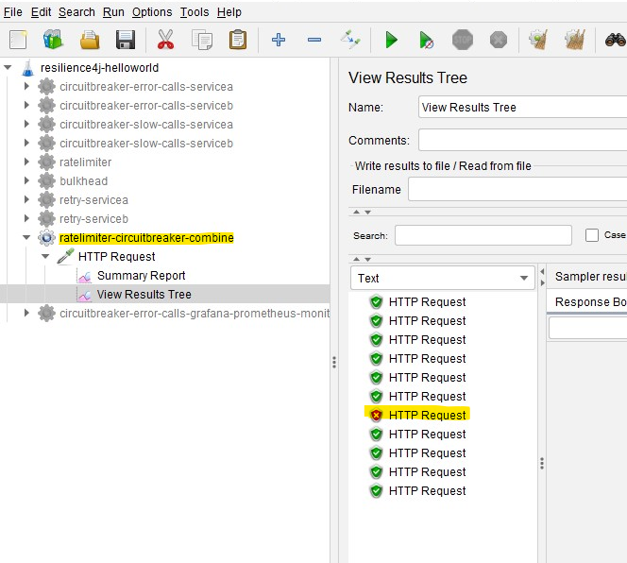
- Observe only 10 calls are successful and rest 1 failed

Code
Include following artifacts as dependency for spring boot restapi ServiceA application. resilience4j-spring-boot2, spring-boot-starter-actuator,spring-boot-starter-aop pom.xml for ServiceA
<dependency>
<groupId>io.github.resilience4j</groupId>
<artifactId>resilience4j-spring-boot2</artifactId>
<version>1.4.0</version>
</dependency>
<dependency>
<groupId>org.springframework.boot</groupId>
<artifactId>spring-boot-starter-actuator</artifactId>
</dependency>
<dependency>
<groupId>org.springframework.boot</groupId>
<artifactId>spring-boot-starter-aop</artifactId>
</dependency>
In application.yml of ServiceA define the behavior of Circuit Breaker and Ratelimiter module
resilience4j:
circuitbreaker:
circuitBreakerAspectOrder: 2
configs:
default:
slidingWindowSize: 10
slidingWindowType: COUNT_BASED
minimumNumberOfCalls: 5
permittedNumberOfCallsInHalfOpenState: 3
automaticTransitionFromOpenToHalfOpenEnabled: true
waitDurationInOpenState: 1s
instances:
greetingCircuit:
baseConfig: default
failureRateThreshold: 50
recordExceptions:
- org.springframework.web.client.HttpServerErrorException
ratelimiter:
rateLimiterAspectOrder: 1
configs:
default:
limitForPeriod: 10
limitRefreshPeriod: 1s
timeoutDuration: 0
instances:
greetingRateLimit:
baseConfig: default
@GetMapping("/greeting")
@RateLimiter(name = "greetingRateLimit", fallbackMethod = "greetingFallBack")
@CircuitBreaker(name = "greetingCircuit", fallbackMethod = "greetingFallBack")
public ResponseEntity greeting(@RequestParam(value = "name", defaultValue = "World") String name) {
ResponseEntity responseEntity = restTemplate.getForEntity("http://localhost:8081/serviceBgreeting?name=" + name, String.class);
//update cache
cache = responseEntity.getBody().toString();
return responseEntity;
}

//Invoked when circuit is in open state
public ResponseEntity greetingFallBack(String name, io.github.resilience4j.circuitbreaker.CallNotPermittedException ex) {
System.out.println("Circuit is in open state no further calls are accepted");
//return data from cache
return ResponseEntity.ok().body(cache);
}

//Invoked when call to serviceB failed
public ResponseEntity greetingFallBack(String name, HttpServerErrorException ex) {
System.out.println("Exception occurred when call calling service B");
//return data from cache
return ResponseEntity.ok().body(cache);
}

//Invoked when Ratelimter is applied
public ResponseEntity greetingFallBack(String name, io.github.resilience4j.ratelimiter.RequestNotPermitted ex) {
System.out.println("Rate limit applied no further calls are accepted");

HttpHeaders responseHeaders = new HttpHeaders();
responseHeaders.set("Retry-After", "1"); //retry after one second

return ResponseEntity.status(HttpStatus.TOO_MANY_REQUESTS)
.headers(responseHeaders) //send retry header
.body("Too many request - No further calls are accepted");
}
ServiceB is a simple rest api application, which generates 50% of faiulres
Random random = new Random(-6732303926L);
@GetMapping("/serviceBgreeting")
public ResponseEntity greeting(@RequestParam(value = "name", defaultValue = "**ServiceB**") String name) {
return generateErrorBehavior(name);
}

private ResponseEntity generateErrorBehavior(String name) {
int i = random.nextInt(2);
if (i == 0) {
System.out.println("Service B Generated Exception");
return ResponseEntity.status(HttpStatus.INTERNAL_SERVER_ERROR).body("Service B Generated Exception");
}
return ResponseEntity.ok().body("Hello " + name);
}

Weblink
- https://eduami.org/Resilience4j/ratelimiter-circuitbreaker-combine.html

References
- https://resilience4j.readme.io/docs/circuitbreaker
- https://developer.mozilla.org/en-US/docs/Web/HTTP/Status
- https://www.baeldung.com/resilience4j
- Hands-On Microservices with Spring Boot and Spring Cloud: Build and deploy Java microservices using Spring Cloud, Istio, and Kubernetes -Magnus Larsson

Next Tutorial
How to deploy microservices using docker
- https://github.com/balajich/spring-cloud-session-6-microservices-deployment-docker
Resilience4j Building Fault Tolerant REST API

Resilience4j Session-5 Preventing cascading of slowness in REST API using Circuit Breaker
In this tutorial we are going to learn how to prevent cascading of slowness from one service to other service using Resilience4j Circuit Breaker module.
For example if a ServiceA depends up on ServiceB. For some reason ServiceB is experiencing slowness instead of repeatedly calling ServiceB, the ServiceA should take a break (not calling) until ServiceB is completely or half recovered.
- This functionality can be achieved easily with annotation @CircuitBreaker without writing explicit code.
Overview
- User makes a call to get greeting message from REST API ServiceA
- ServiceA calls ServiceB to fetch greeting message
- The usual response time of ServiceB is 10 milliseconds, Because of some random issue 50% of calls to ServiceB takes more than 2 seconds.
- This slowness behavior of ServiceB shouldn't impact ServiceA.
- When ever ServiceA sees 50% (out of 5 ) are taking more than 10 milliseconds, it is not going to call ServiceB and returns the response from cachce.
- This entire functionality can be achieved with Circuit Breaker pattern

Source Code
- https://github.com/balajich/resilience4j-helloworld/tree/master/circuitbreaker-slow-calls

Video
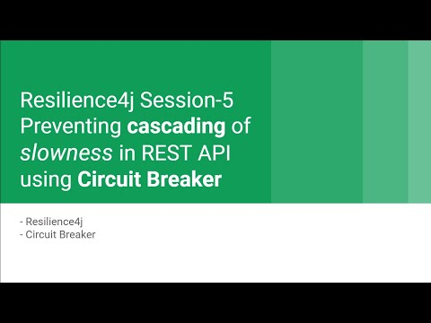
- https://youtu.be/WKxV0bmA_eQ

Architecture
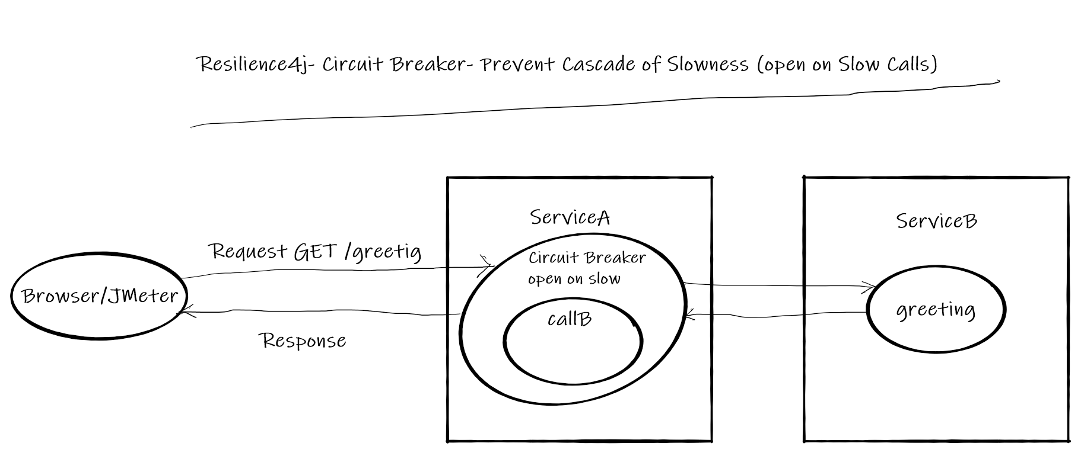

Normal Call flow

Call flow with Circuit Breaker

Prerequisite
- JDK 1.8 or above
- Apache Maven 3.6.3 or above

Build
- cd resilience4j-helloworld\circuitbreaker-slow-calls
- mvn clean install

Running
- ServiceA: java -jar .\servicea\target\servicea-0.0.1-SNAPSHOT.jar
- ServiceB: java -jar .\serviceb\target\serviceb-0.0.1-SNAPSHOT.jar

Using JMeter to test environment
- JMeter Script is provided to generate call.
- Import resilience4j-helloworld.jmx and run circuitbreaker-slow-calls-serviceb thread group.
- This will generate 20 requests and Observe 50% of calls are taking 2 seconds and average response time 1.014 seconds
- 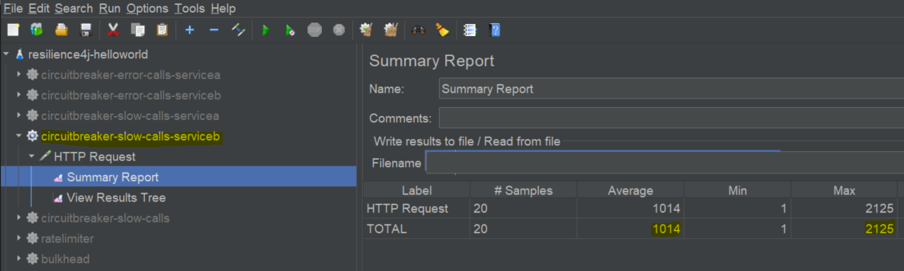
- run circuitbreaker-error-calls-servicea thread group.
- Observe the average response time is significantly dropped to 0.214 seconds
- The reason for improvement in performance is. The ServiceA doesn't call ServiceB when there is a drop in performance instead it serves from a cache.
- 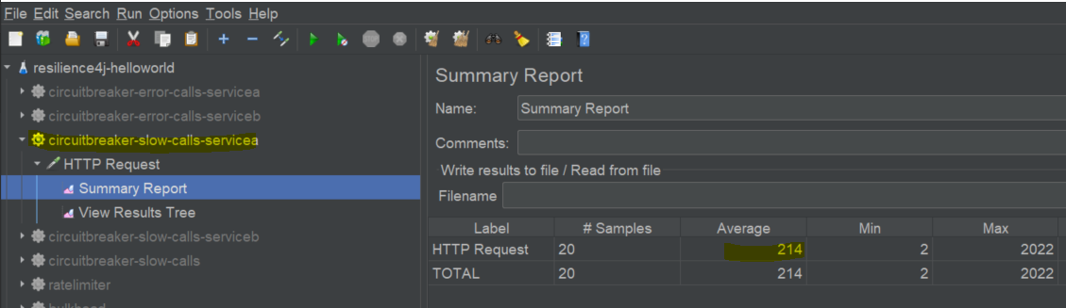

Code
Include following artifacts as dependency for spring boot restapi serviceA application. resilience4j-spring-boot2, spring-boot-starter-actuator,spring-boot-starter-aop pom.xml of ServiceA
<dependency>
<groupId>io.github.resilience4j</groupId>
<artifactId>resilience4j-spring-boot2</artifactId>
<version>1.4.0</version>
</dependency>
<dependency>
<groupId>org.springframework.boot</groupId>
<artifactId>spring-boot-starter-actuator</artifactId>
</dependency>
<dependency>
<groupId>org.springframework.boot</groupId>
<artifactId>spring-boot-starter-aop</artifactId>
</dependency>
In application.yml of serviceA define the behavior of Circuit Breaker module
- slidingWindowSize: Configures the size of the sliding window which is used to record the outcome of calls when the CircuitBreaker is closed.
- slidingWindowType: Configures the type of the sliding window which is used to record the outcome of calls when the CircuitBreaker is closed
- minimumNumberOfCalls: Configures the minimum number of calls which are required (per sliding window period) before the CircuitBreaker can calculate the error rate or slow call rate.
- waitDurationInOpenState: The time that the CircuitBreaker should wait before transitioning from open to half-open.
- slowCallRateThreshold: Configures a threshold in percentage. The CircuitBreaker considers a call as slow when the call duration is greater than slowCallDurationThreshold
- slowCallDurationThreshold: Configures the duration threshold above which calls are considered as slow and increase the rate of slow calls.
resilience4j:
circuitbreaker:
configs:
default:
slidingWindowSize: 10
slidingWindowType: COUNT_BASED
minimumNumberOfCalls: 5
permittedNumberOfCallsInHalfOpenState: 3
automaticTransitionFromOpenToHalfOpenEnabled: true
waitDurationInOpenState: 5s
instances:
greetingCircuitSlow:
baseConfig: default
slowCallRateThreshold: 50
slowCallDurationThreshold: 10ms
@GetMapping("/greeting")
@CircuitBreaker(name = "greetingCircuitSlow", fallbackMethod = "greetingFallBack")
public ResponseEntity greeting(@RequestParam(value = "name", defaultValue = "World") String name) {
ResponseEntity responseEntity = restTemplate.getForEntity("http://localhost:8081/serviceBgreeting?name=" + name, String.class);
//update cache
cache = responseEntity.getBody().toString();
return responseEntity;
}

//Invoked when circuit is in open state
public ResponseEntity greetingFallBack(String name, io.github.resilience4j.circuitbreaker.CallNotPermittedException ex) {
System.out.println("Circuit is in open state no further calls are accepted");
//return data from cache
return ResponseEntity.ok().body(cache);
}

//Invoked when call to serviceB failed
public ResponseEntity greetingFallBack(String name, HttpServerErrorException ex) {
System.out.println("Exception occurred when call calling service B");
//return data from cache
return ResponseEntity.ok().body(cache);
}
ServiceB is a simple rest api application, where 50% of calls take 2 seconds
Random random = new Random(-6732303926L);
@GetMapping("/serviceBgreeting")
public ResponseEntity greeting(@RequestParam(value = "name", defaultValue = "serviceB") String name) {
return generateSlowBehavior(name);
}

private ResponseEntity generateSlowBehavior(String name) {
int i = random.nextInt(2);
if (i == 0) {
try {
Thread.sleep(2*1000);//sleep for two seconds
} catch (InterruptedException interruptedException) {
interruptedException.printStackTrace();
}
}//end of if
return ResponseEntity.ok().body("Hello " + name);
}

References
- https://resilience4j.readme.io/docs/circuitbreaker
- https://developer.mozilla.org/en-US/docs/Web/HTTP/Status
- https://www.baeldung.com/resilience4j
- Hands-On Microservices with Spring Boot and Spring Cloud: Build and deploy Java microservices using Spring Cloud, Istio, and Kubernetes -Magnus Larsson

Next Tutorial
How to deploy microservices using docker
- https://github.com/balajich/spring-cloud-session-6-microservices-deployment-docker

Resilience4j Session-7 Monitoring CircuitBreaker Events with Prometheus and visualizing them in Grafana
In this tutorial we are going to learn how to monitor events that are generated by Resilience4j library and visualize them in a dashboard. Here we are going to use Prometheus to monitor events and Grafana for visualization.
In this example we are going to monitor Circuit Breaker events that are generated by ServiceA when it is receiving more errors than those are expected from ServiceB.
Overview
- User makes a call to get greeting message from REST API ServiceA
- ServiceA calls ServiceB to fetch greeting message
- Because of some random issue 50% of calls to ServiceB results in failure
- When ever ServiceA gets error message from ServiceB instead of returning error message to client, it will return message from a cache.
- When ever error rate increases beyond 50% ServiceA doesn't call ServiceB until ServiceB recovers or waitDurationInOpenState is finished.
- ServiceA uses CircuitBreaker module from Resilience4j. When ever there is a change in circuit state and event is generated.
- For every 5 seconds interval Prometheus asks ServiceA for Circuit Breaker events using REST API
- For every 5 seconds interval Garafana updates its dashboard with newly generate event count. Note: We are not going discuss details of Circuit Breaker in this session. Please refer to my previous sessions.

Source Code
- https://github.com/balajich/resilience4j-helloworld/tree/master/circuitbreaker-error-calls-grafana-prometheus-monitor

Video
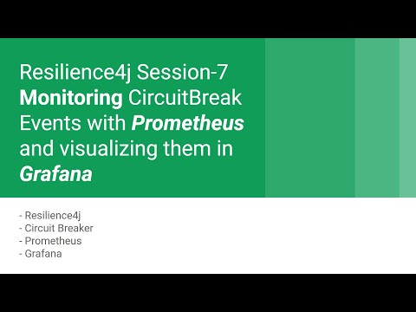
- https://youtu.be/4ZVY099kF9A

Architecture
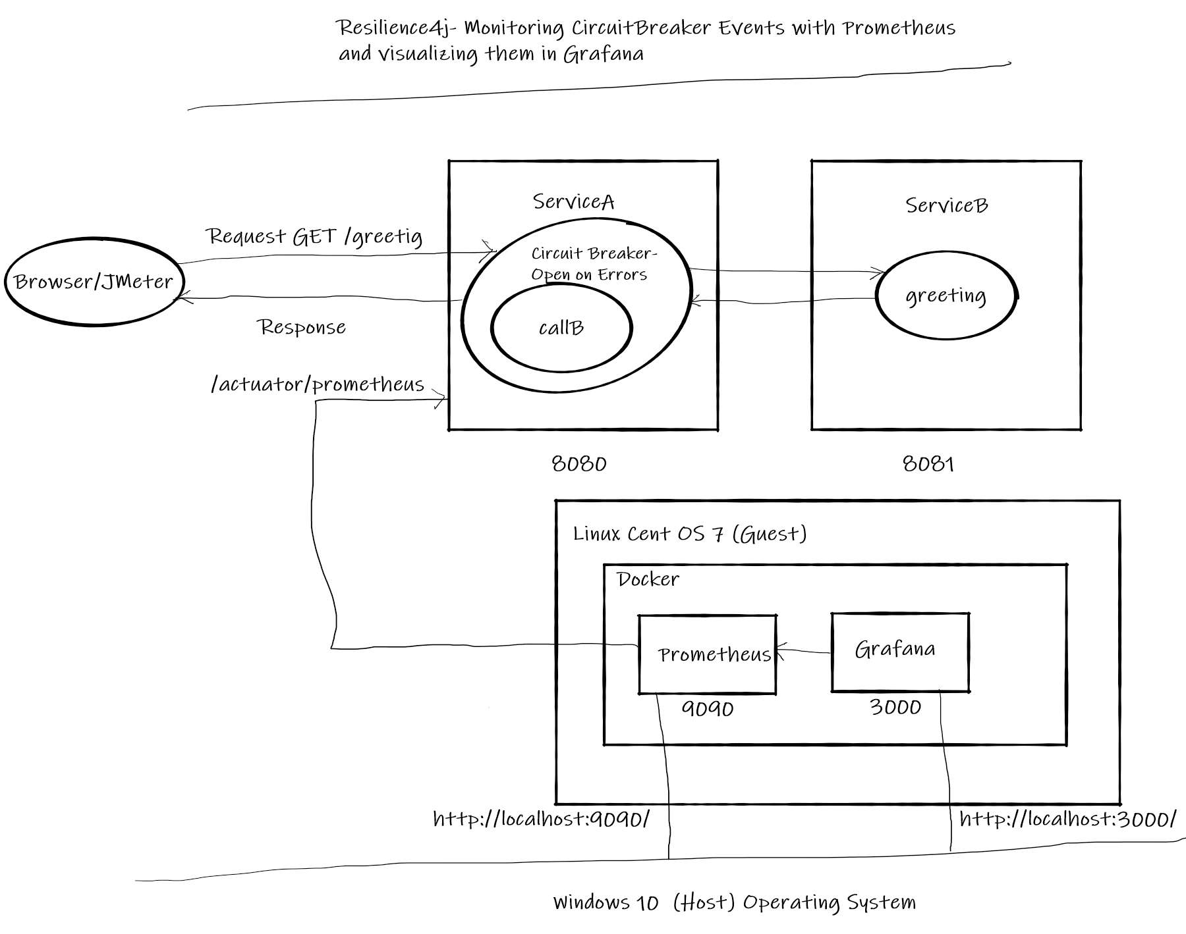

Prerequisite
- JDK 1.8 or above
- Apache Maven 3.6.3 or above
- Vagrant 2.2.9 or above- (To start,stop and manage virtual machines)
- Docker version 19.03.13 or above
- docker-compose version 1.18.0 or above

Step 1: Build
- cd resilience4j-helloworld\circuitbreaker-error-calls-grafana-prometheus-monitor
- mvn clean install

Step 2: Running Prometheus and Grafana in docker
- cd resilience4j-helloworld
- vagrant up # wait till the virtual machine is up
- vagrant ssh -- -R 8080:localhost:8080 # Take ssh to virtual machine and route requests from guest 8080 to host 8080 using ssh tunnel. Prometheus that is running in docker in the virtual machine should be able to access ServiceB tomcat to fetch metrics.
- sudo su - # Change to root user
- cd /vagrant/circuitbreaker-error-calls-grafana-prometheus-monitor
- Start Prometheus and Grafana docker-compose up -d # Run them in background mode Note: If you are running docker on physical machine, Please ignore vagrant and ssh forward commands.

Step 3: Run Services
- cd resilience4j-helloworld\circuitbreaker-error-calls-grafana-prometheus-monitor
- ServiceA: java -jar .\servicea\target\servicea-0.0.1-SNAPSHOT.jar
- ServiceB: java -jar .\serviceb\target\serviceb-0.0.1-SNAPSHOT.jar

Prometheus metrics endpoint on ServiceA (Tomcat)
- curl -l -s http://localhost:8080/actuator/prometheus Prometheus scrapes metrics from the endpoint "/actuator/prometheus"

Step 4: Prometheus UI
View the UI to see that it is able to read metrics from ServiceA
- http://localhost:9090/targets
- 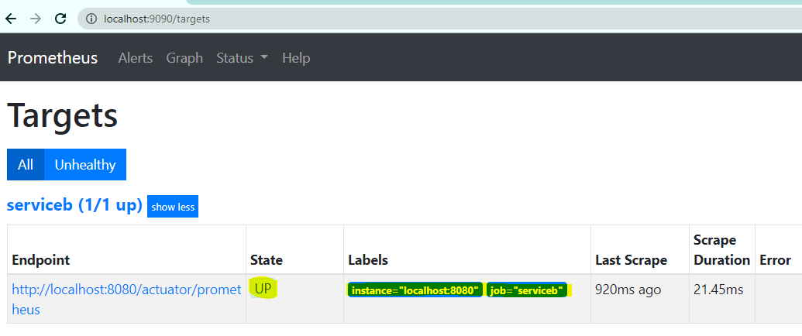 Few useful prometheus queries.
- sum(resilience4j_circuitbreaker_state{state='closed'}) Get sum of closed circuits
- rate(resilience4j_circuitbreaker_calls_seconds_count{instance="localhost:8080",name="greetingCircuit"}[1m]) Counters to track how many circuitbreaker events have happened

Step 5: Grafana UI
Access Garafan UI and use admin/admin as credentails.
- open http://localhost:3000/
- Configure integration with Prometheus
  - Access configuration
  - Add data source
  - Select Prometheus
  - Use url "http://localhost:9090" and access with value "Browser"
- Configure dashboard
  - Access "home"
  - Import dashboard
  - Upload dashboard.json
- 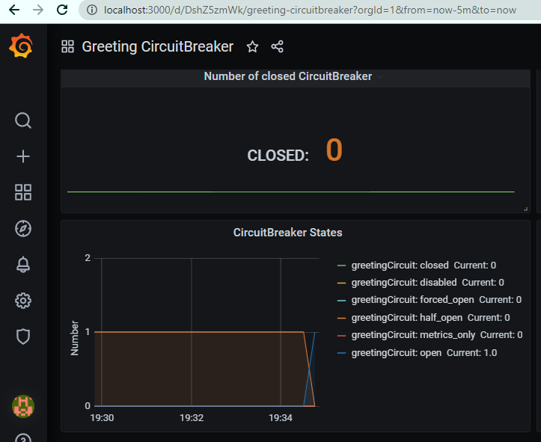

Using JMeter to test environment
- JMeter Script is provided to generate call.
- Import resilience4j-helloworld.jmx and run circuitbreaker-error-calls-grafana-prometheus-monitor-servicea thread group.
- Observe Granfana dashboard for changes in circuit breaker events
- 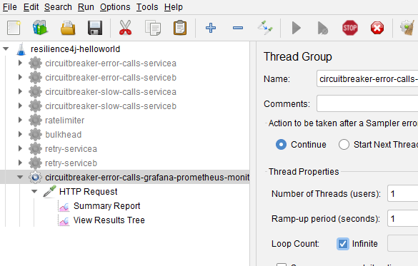

Code
Instrument ServiceA to get meterics using dependency. pom.xml of ServiceA
<dependency>
<groupId>io.micrometer</groupId>
<artifactId>micrometer-registry-prometheus</artifactId>
</dependency>
application.yml , Expose mertics endpoint from ServiceA.
management.endpoints.web.exposure.include: '*'
management.endpoint.health.show-details: always
management.health.diskspace.enabled: false
management.health.circuitbreakers.enabled: true
management.health.ratelimiters.enabled: false
management.metrics.tags.application: servicea
management.metrics.distribution.percentiles-histogram.http.server.requests: true
management.metrics.distribution.percentiles-histogram.resilience4j.circuitbreaker.calls: true
Please refer my previous repos for Circuitbreaker code etc, explaining the docker files and PQL is beyond the scope of this tutorial.

References
- https://github.com/resilience4j/resilience4j-spring-boot2-demo
- https://resilience4j.readme.io/docs/circuitbreaker
- https://developer.mozilla.org/en-US/docs/Web/HTTP/Status
- https://www.baeldung.com/resilience4j
- Hands-On Microservices with Spring Boot and Spring Cloud: Build and deploy Java microservices using Spring Cloud, Istio, and Kubernetes -Magnus Larsson

Weblink
- https://eduami.org/Resilience4j/circuitbreaker-error-calls-grafana-prometheus-monitor.html

Next Tutorial
How to deploy microservices using docker
- https://github.com/balajich/spring-cloud-session-6-microservices-deployment-docker

Resilience4j- Session-2 Limit of number of concurrent requests to RESTAPI using bulkhead
In this tutorial we are going to learn how to limit number of concurrent (parallel) requests that a restapi can handle.
Overview
- Using Bulkhead to limit the number of concurrent calls to a service.
- This functionality can be achieved easily with annotation @Bulkhead without writing explicit code.
Overview
- User makes a call to greeting RESTAPI to get a greeting message.
- greeting api can only handle can only handle 5 concurrent requests at a given time.
- This limitation can be set on greeting method using annotation @Bulkhead
- if the method receives more than 5 concurrent requests at a given time io.github.resilience4j.bulkhead.BulkheadFullException is thrown.The user is served with HTTP status code 503 and asked to retry after 10 seconds.

Source Code
- https://github.com/balajich/resilience4j-helloworld/tree/master/bulkhead

Video
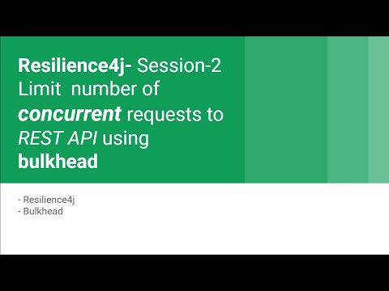
- https://youtu.be/35fTH9G8gT0

Architecture
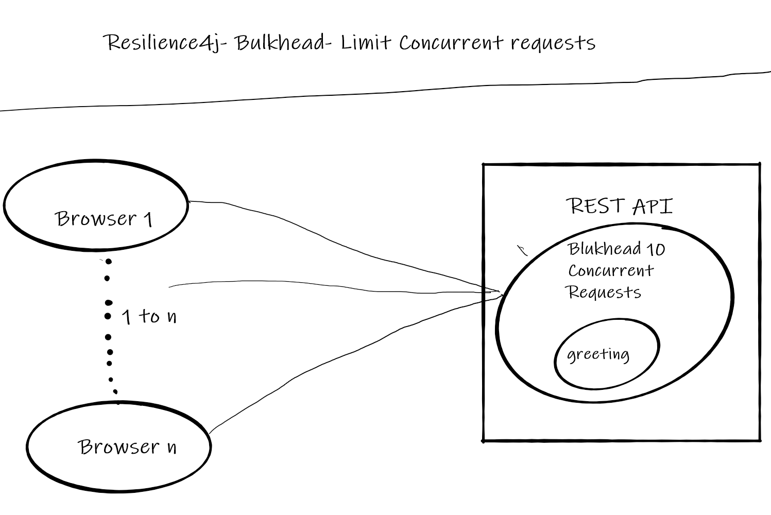

Prerequisite
- User should have basic understanding of RESTAPI and Spring boot
- JDK 1.8 or above
- Apache Maven 3.6.3 or above

Build
- cd resilience4j-helloworld
- mvn clean install

Running RESTAPI
- REST API Server: java -jar .\bulkhead\target\bulkhead-0.0.1-SNAPSHOT.jar

Using JMeter to generate more than 5 concurrent calls
- JMeter Script is provided to generate calls
- Import resilience4j-helloworld.jmx and run bulkhead thread group.
- Obeseve only 5 concurrent calls are successful rest of them fail with 503
- 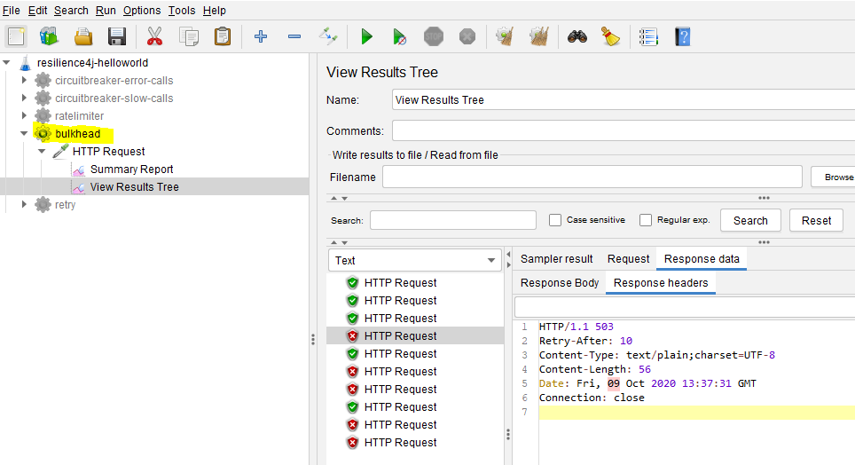

Code
Include following artifacts as dependency for spring boot restapi application. resilience4j-spring-boot2, spring-boot-starter-actuator,spring-boot-starter-aop pom.xml of bulkhead
<dependency>
<groupId>io.github.resilience4j</groupId>
<artifactId>resilience4j-spring-boot2</artifactId>
<version>1.4.0</version>
</dependency>
<dependency>
<groupId>org.springframework.boot</groupId>
<artifactId>spring-boot-starter-actuator</artifactId>
</dependency>
<dependency>
<groupId>org.springframework.boot</groupId>
<artifactId>spring-boot-starter-aop</artifactId>
</dependency>
In application.yml define the behavior of bulkhead module
- maxConcurrentCalls: Number of maximum concurrent calls that it should handle.
- maxWaitDuration: Duration for which request should wait.
resilience4j:
bulkhead:
configs:
default:
maxConcurrentCalls: 5
maxWaitDuration: 0
instances:
greetingBulkhead:
baseConfig: default
@GetMapping("/greeting")
@Bulkhead(name = "greetingBulkhead", fallbackMethod = "greetingFallBack")
public ResponseEntity greeting(@RequestParam(value = "name", defaultValue = "World") String name) {
return ResponseEntity.ok().body("Hello World: " + name);
}

public ResponseEntity greetingFallBack(String name, io.github.resilience4j.bulkhead.BulkheadFullException ex) {
System.out.println("BulkHead applied no further calls are accepted");
HttpHeaders responseHeaders = new HttpHeaders();
responseHeaders.set("Retry-After", "10"); //retry after 10 seconds

return ResponseEntity.status(HttpStatus.SERVICE_UNAVAILABLE)
.headers(responseHeaders) //send retry header
.body("Too many concurrent requests- Please try after some time");
}

References
- https://developer.mozilla.org/en-US/docs/Web/HTTP/Status
- https://www.baeldung.com/resilience4j
- Hands-On Microservices with Spring Boot and Spring Cloud: Build and deploy Java microservices using Spring Cloud, Istio, and Kubernetes -Magnus Larsson

Next Tutorial
How to deploy microservices using docker
- https://github.com/balajich/spring-cloud-session-6-microservices-deployment-docker

Spring Cloud Session 4 Inter Microservice Communication ASynchronous using RabbitMQ
In this tutorial we are going to learn how microservices communicate with each other in asynchronous fashion. In asynchronous communication calling microservice will not wait till the called microservice responds. This pattern can be achieved with message bus infrastructures like Kafka or RabbitMQ.Here we use Spring Cloud Stream framework to communicate with message bus.
Overview
- When report-api microservice receives a request to get employee details it is going to fetch details and write results to message bus.
- Mail microservice listens on the bus for employee details and when those details are available on bus. It is going to read send SMS and email.
- report-api play a role of Producer
- mail-client microservice plays a role of Consumer
- RabbitMQ play a role of mediator or message bus
Flow
- Run RabbitMQ server, it binds to port 5672 and admin ui application to port 15672.
- Run registry service on 8761.
- Run employee-api service on dynamic port. Where it takes employee id and returns employee name.
- Run payroll-api service on dynamic port. Where it takes employee id and returns employee salary.
- Run report-api service on dynamic port. Where it takes employee id and returns employee name and salary by directly communicating with employee-api and payroll-api. It also publishes employee details to message bus
- Run mail-client service (it is not a rest api, it a java process and doesnt bind to any port). Where it subscribes to message bus for employee details message and sends mail,sms.
- Run Gateway service on 8080 and reverse proxy requests to all the services (employee-api,payroll-api,report-api)
- All the microservices (employee-api,payroll-api,report-api,gateway) when they startup they register their service endpoint (rest api url) with registry
- Gateway Spring Cloud load balancer (Client side load balancing) component in Spring Cloud Gateway acts as reverse proxy. It reads a registry for microservice endpoints and configures routes.
Important Notes
- Netflix Eureka Server plays a role of Registry. Registry is a spring boot application with Eureka Server as dependency.
- Netflix Eureka Client is present in all the micro services (employee-api,payroll-api,report-api,gateway) and they discover Eureka server and register their availability with server.
- Generally Netflix Ribbon Component is used as Client Side load balancer, but it is deprecated project. We will be using Spring Cloud Load balaner in gateway

RabbitMQ Terminology
- Producer, publisher A Producer is the application that is sending the messages to the message queue.
- Consumer A Consumer is the application that receives the messages from the message queue.
- Message queue- A message queue is a queue of messages sent between applications. It allow applications to communicate by sending messages to each other.
- Exchange An exchange is responsible for the routing of the messages to the different queues. An exchange accepts messages from the producer application and routes them to message queues with help of header attributes, bindings, and routing keys
- Ack When RabbitMQ delivers a message to a consumer, it needs to know when to consider the message successfully sent. An ack will acknowledge one or more messages, which tells RabbitMQ that a message/messages has been handled
- Binding A binding is a "link" that you set up to bind a queue to an exchange.
- Channel A channel is a virtual connection inside a connection. When you are publishing or consuming messages from a queue - it's all done over a channel.
- Connection-A connection is a TCP connection between your application, and the RabbitMQ broker

Spring Cloud Stream Concepts
Spring cloud stream abstracts underneath communication with Messagebus. This helps to foucs on business logic instead of nettigritty of message bus. We can easily switch from RabbitMQ to Kafka etc without code changes.
- Bindings — a collection of interfaces that identify the input and output channels.
- Channel — represents the communication pipe between messaging-middleware and the application.
- StreamListeners- Listens to messages on Input channel and serializes them to java objects.

Source Code
git clone https://github.com/balajich/spring-cloud-session-4-inter-microservice-communication-async.git

Video
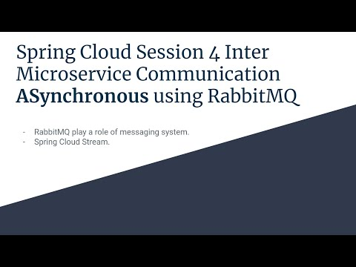
- https://youtu.be/8CV8PDX8Kuc

Architecture
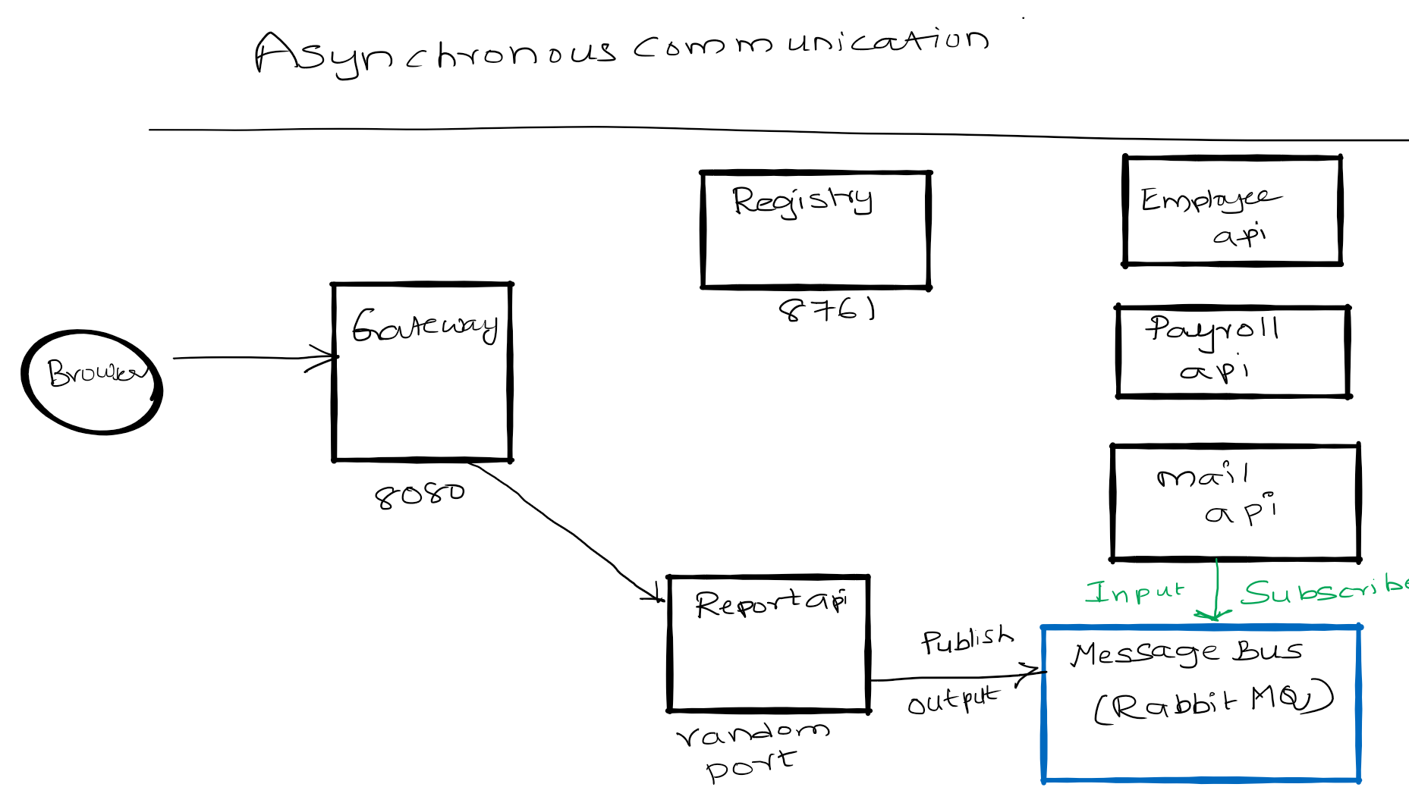

Prerequisite
- JDK 1.8 or above
- Apache Maven 3.6.3 or above
- Vagrant, Virtualbox (To run RabbitMQ Server)

Start RabbitMQ Server and Build Microservices
We will be running RabbitMQ server inside a docker container. I am running docker container on CentOS7 virtual machine. I will be using vagrant to stop or start a virtual machine.
- Build Employee API docker image docker build -t product-service .
- View the built employee api docker image docker images | grep employee-api
- Run employee-api in docker image docker run --rm -p8080:8080 -e "SPRING_PROFILES_ACTIVE=docker" employee-api
- RabbitMQ Server
  - cd spring-cloud-session-4-inter-microservice-communication-async
  - Bring virtual machine up vagrant up
  - ssh to virtual machine vagrant ssh
  - Switch to root user sudo su -
  - Change folder where docker-compose files is available cd /vagrant
  - Start RabbitMQ Server using docker-compose docker-compose up -d
- Java
  - mvn clean install

RabbitMQ Server UI
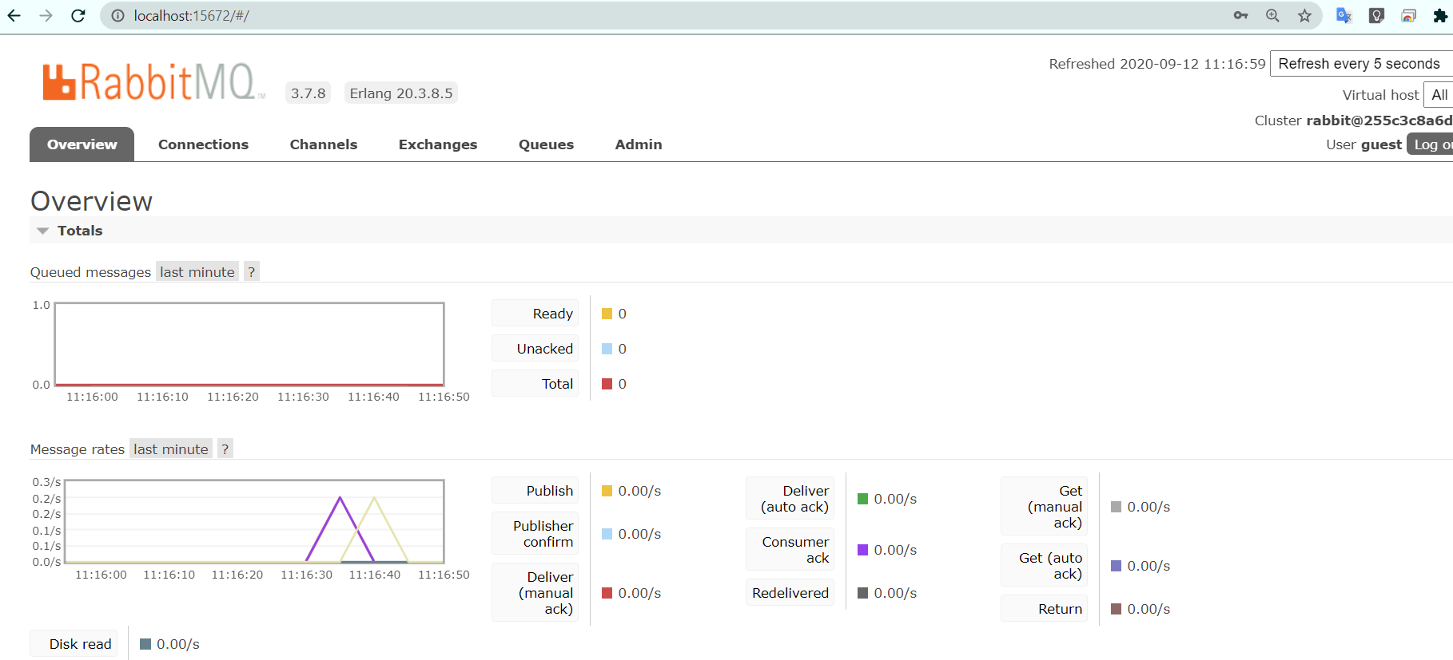

Running components
- Registry: java -jar .\registry\target\registry-0.0.1-SNAPSHOT.jar
- Employee API: java -jar .\employee-api\target\employee-api-0.0.1-SNAPSHOT.jar
- Payroll API: java -jar .\payroll-api\target\payroll-api-0.0.1-SNAPSHOT.jar
- Report API: java -jar .\report-api\target\report-api-0.0.1-SNAPSHOT.jar
- Mail Client App: java -jar .\mail-client\target\mail-client-0.0.1-SNAPSHOT.jar
- Gateway: java -jar .\gateway\target\gateway-0.0.1-SNAPSHOT.jar

Using curl to test environment
Note I am running CURL on windows, if you have any issue. Please use postman client, its collection is available at spring-cloud-session-3-inter-microservice-communication-sync.postman_collection.json
- Access RabbitMQ UI: http://localhost:15672/
- RabbitMQ defaults username/password: guest/guest
- Get employee report using report api ( direct): curl -s -L http://localhost:8080/report-api/100

Scale up
- Deprecated docker-compose scale employee-api=2
- Spin instance docker-compose up --scale employee-api=2 -d

Code
In this section will focus only on report-api code which publishes employee details to queue queue.email
ReportController in app report-api. @SendTo(Processor.OUTPUT) makes the function to invoke RabbitMQ and writes details to MQ.
@SendTo(Processor.OUTPUT)
public Employee getEmployeeDetails(@PathVariable int employeeId) {

Employee finalEmployee = new Employee(responseEmployeeNameDetails.getId(), responseEmployeeNameDetails.getName(), responseEmployeePayDetails.getSalary());
// Send to message bus
processor.output().send(MessageBuilder.withPayload(finalEmployee).build());

}
application.yml in report-api.
cloud:
stream:
bindings:
output:
destination: queue.email
binder: local_rabbit
binders:
local_rabbit:
type: rabbit
environment:
spring:
rabbitmq:
host: localhost
port: 5672
username: guest
password: guest
virtual-host: /
mail-client code that reads messages from queue. @StreamListener(Processor.INPUT) reads data from queue email.queue
@SpringBootApplication
@EnableBinding(Processor.class)
public class MailClientApplication {

public static void main(String[] args) {
SpringApplication.run(MailClientApplication.class, args);
}

@StreamListener(Processor.INPUT)
public void receivedEmail(Employee employee) {
System.out.println("Received employee details: " + employee);
System.out.println("Sending email and sms: "+employee.getName());
}

}
application.yml of mail-client
application:
name: email-api
cloud:
stream:
bindings:
input:
destination: queue.email
binder: local_rabbit
group: emailconsumers
binders:
local_rabbit:
type: rabbit
environment:
spring:
rabbitmq:
host: localhost
port: 5672
username: guest
password: guest
virtual-host: /

References
- https://www.baeldung.com/spring-cloud-stream
- Spring Microservices in Action by John Carnell
- Hands-On Microservices with Spring Boot and Spring Cloud: Build and deploy Java microservices using Spring Cloud, Istio, and Kubernetes -Magnus Larsson
- https://www.cloudamqp.com/blog/2017-07-25-RabbitMQ-and-AMQP-concepts-glossary.html

Next Tutorial
We will learn how to use kafka as message bus
- https://github.com/balajich/spring-cloud-session-4-inter-microservice-communication-async-kafka

